# Introduction

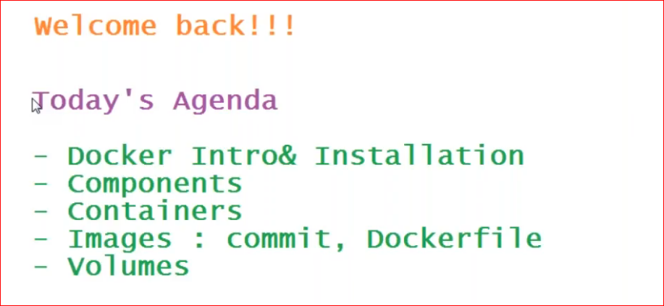

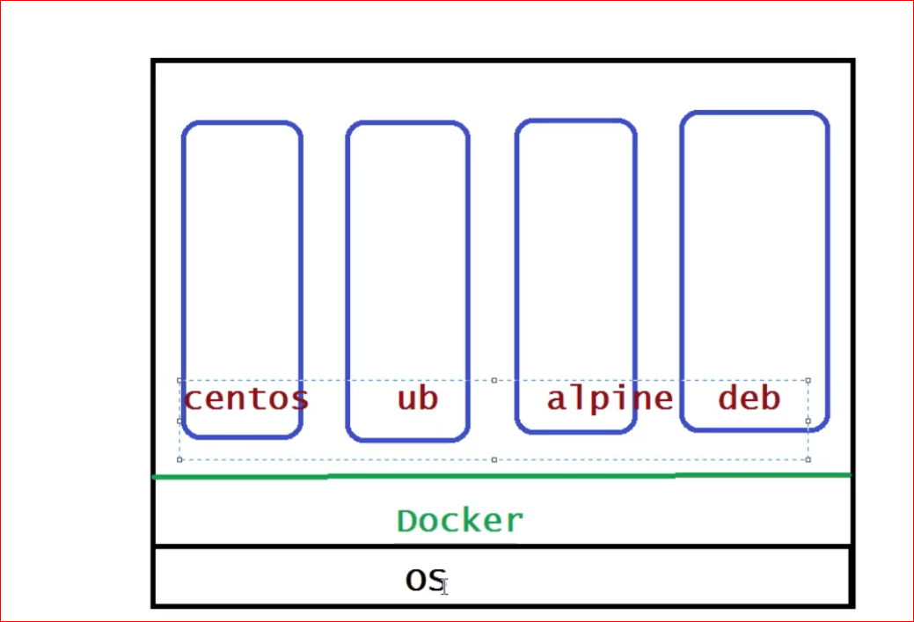

**Above screen shows the docker container within a docker. Each container can have its own operating system, called it as lightweight os and its own application stack.**

The code running in one environment will run in any of the env like dev, qa, uat and prod

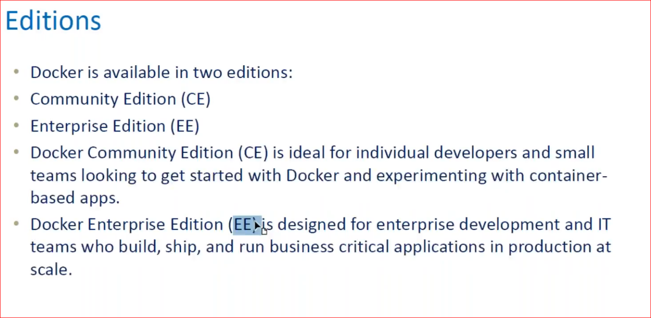

# Docker components

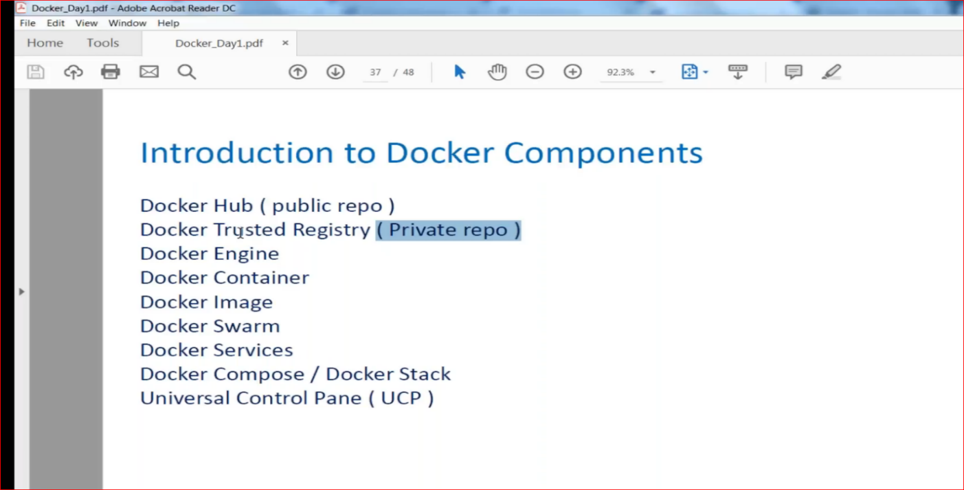

1. Docker installation

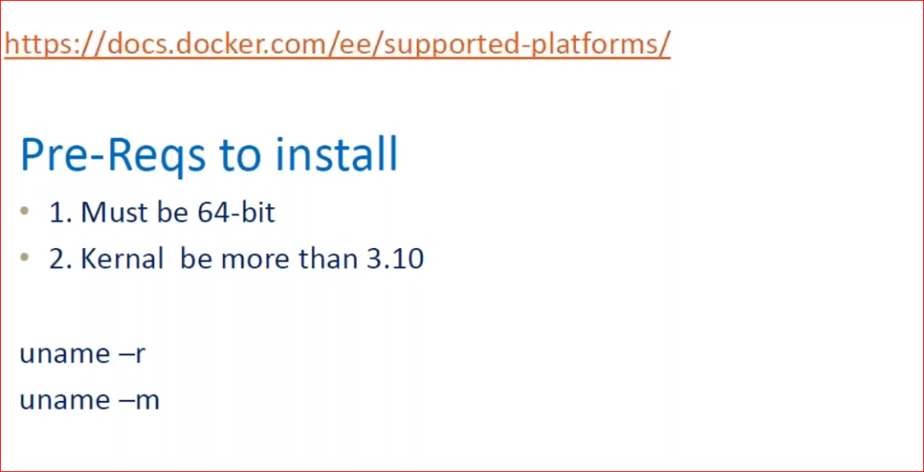

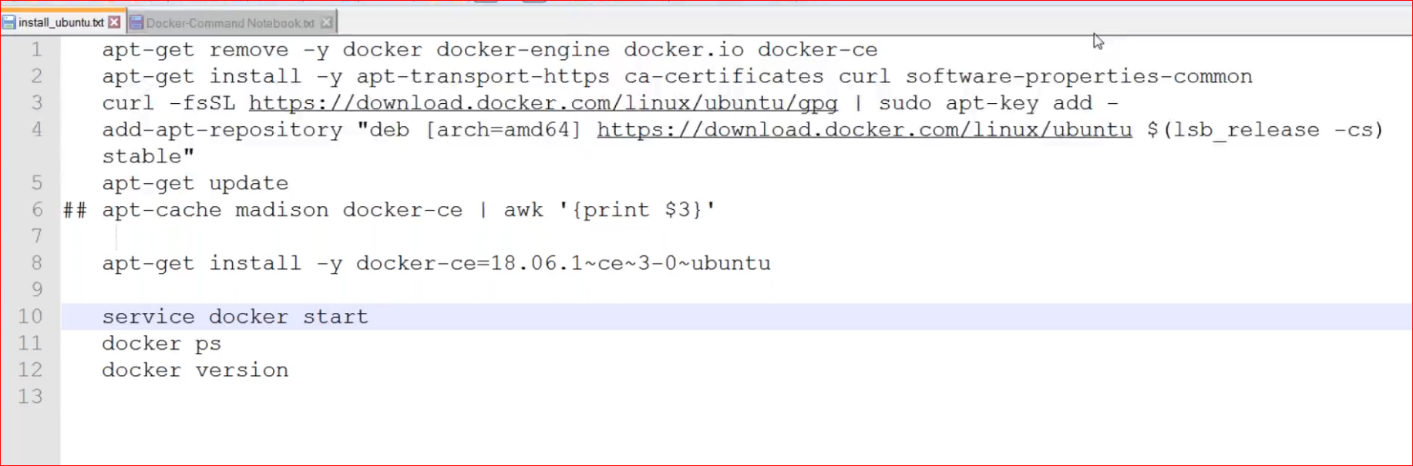

Install docker using above shown commands

:Add repository of docker

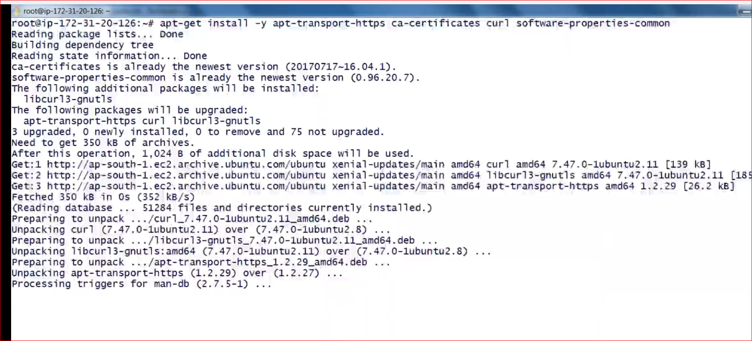

How to check the version:

Client here is the command prompt to talk to docker, every command for docker starts with the keyword **docker**

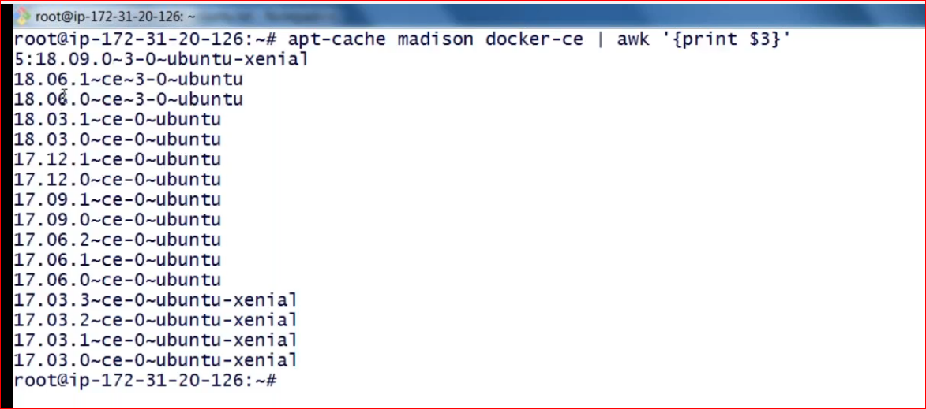

All the docker related data installed at

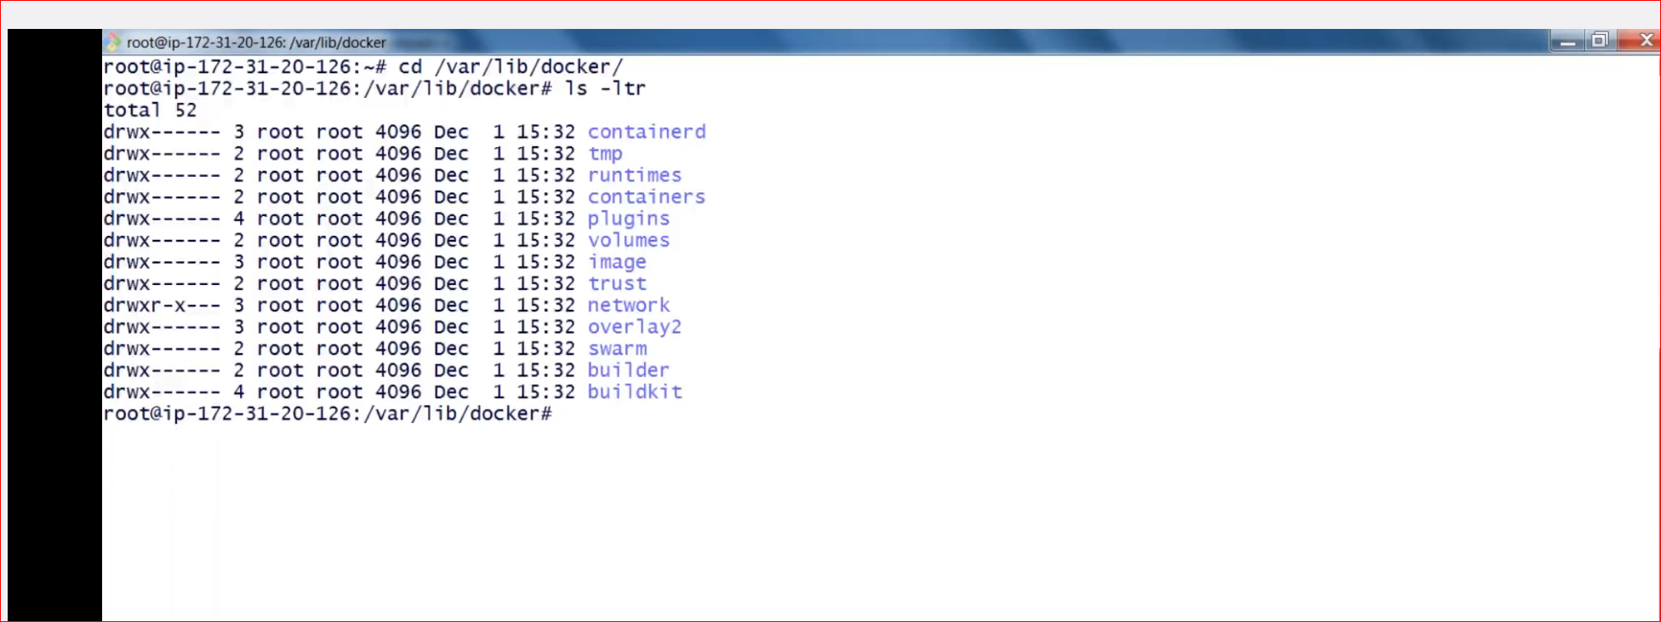

Stop Start Docker

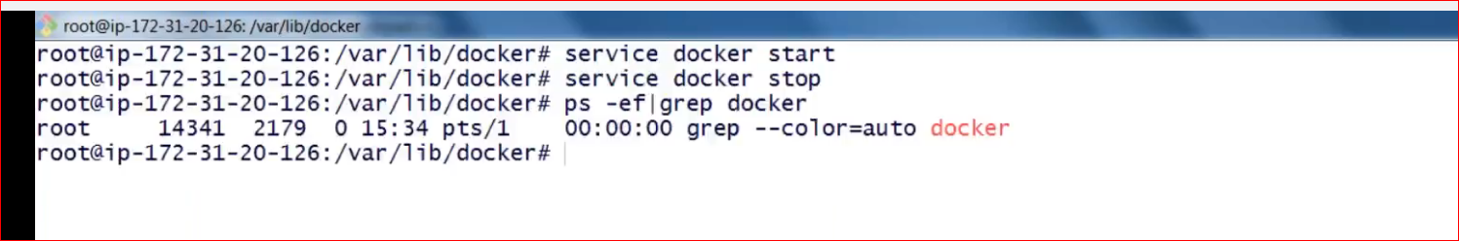

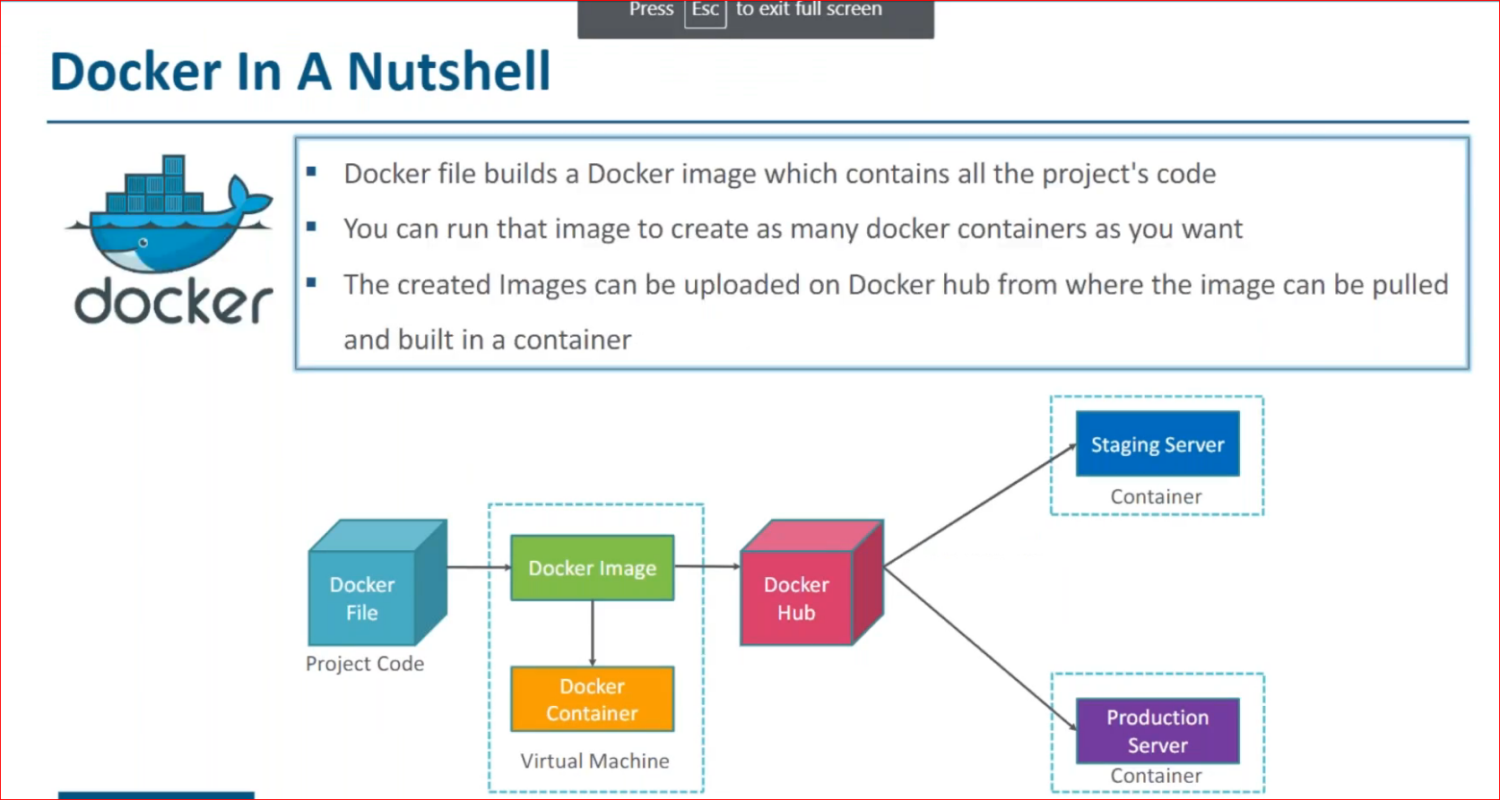

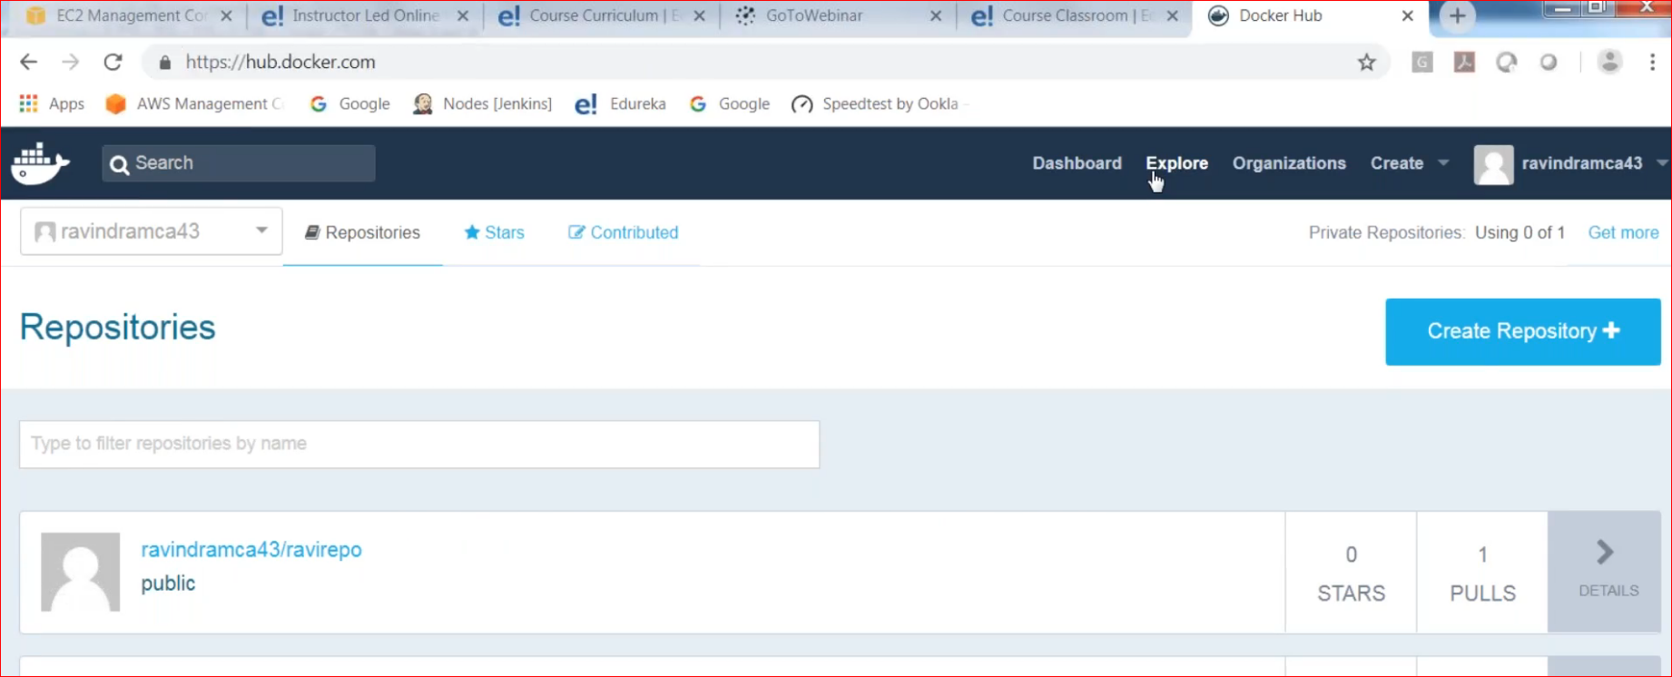

How to see docker images

>docker images

Docker search:

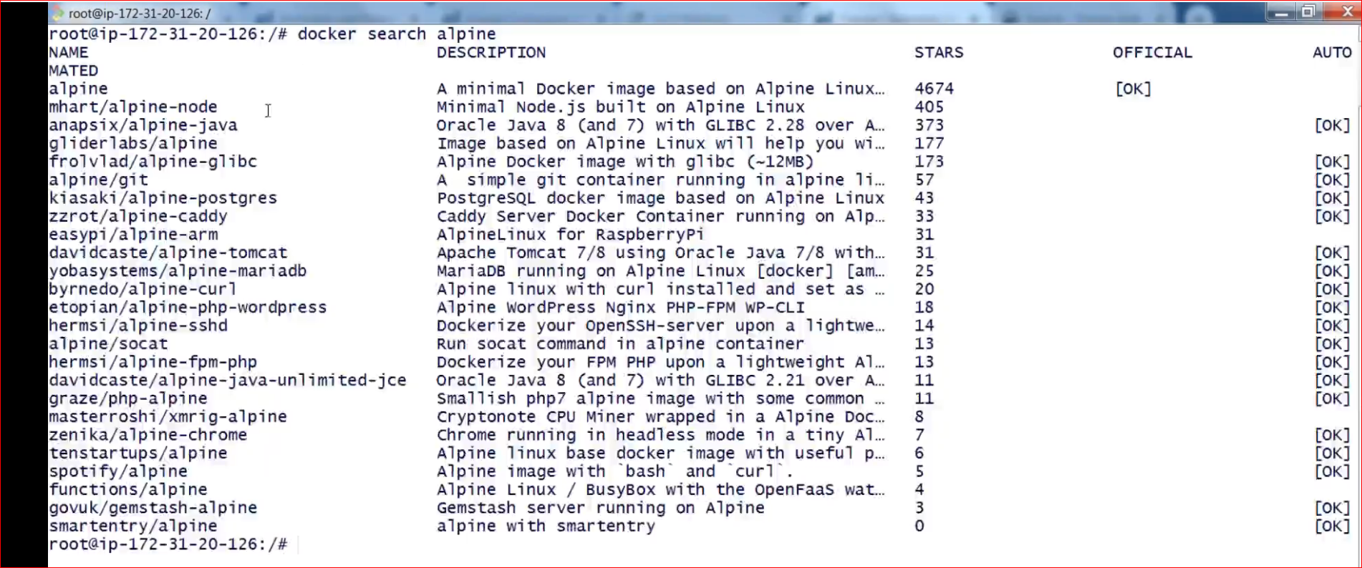

Docker pull: Always go for Official image

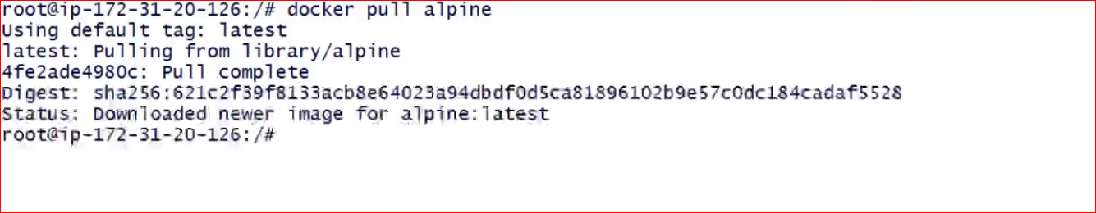

See the image



Run the image or container

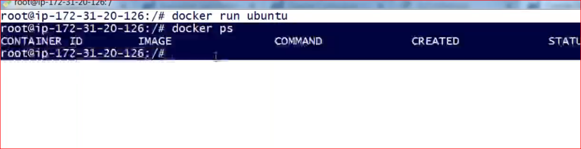

**docker ps** is the command to see the running container, so we are not able to see any containers running

to see all use **docker ps -a**

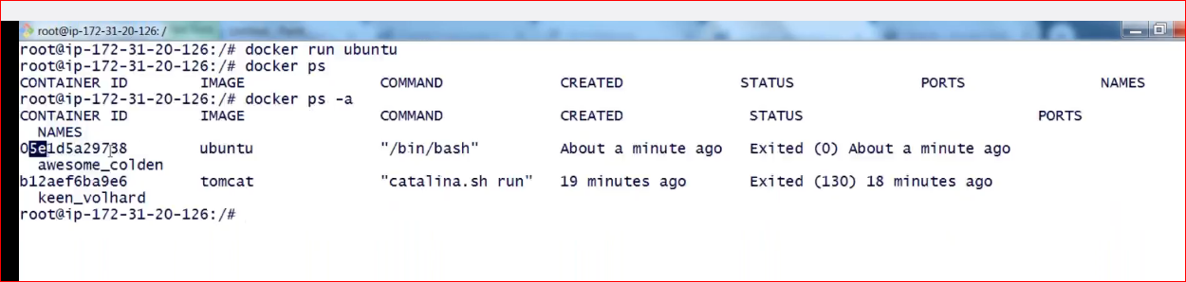

Run the container in detached mode and see it

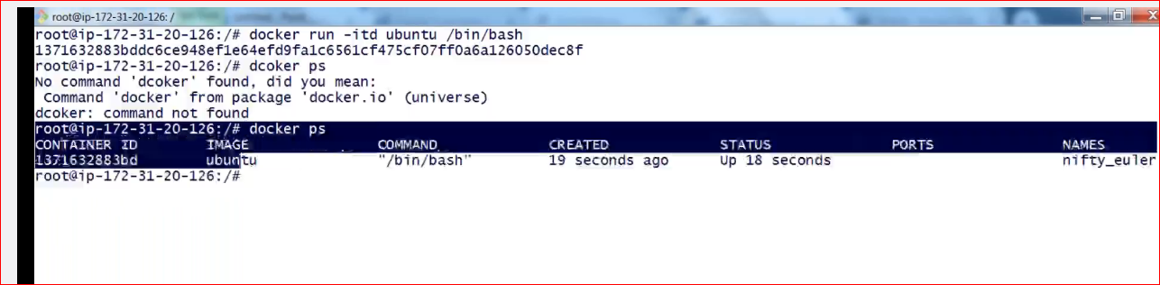

Container id is something docker fetches from ur machine randomly. Here **itd** stands for interactive terminal and detach

Detach mode means just run it no need to go inside the container

Eg running a tomcat

But if you want to work with any operating system as like Ubuntu…then try interactive mode as

**docker run -it ubuntu /bin/bash**

now you are not in ur host machine instead u r inside ubuntu os, to exit press ctrl+PQ

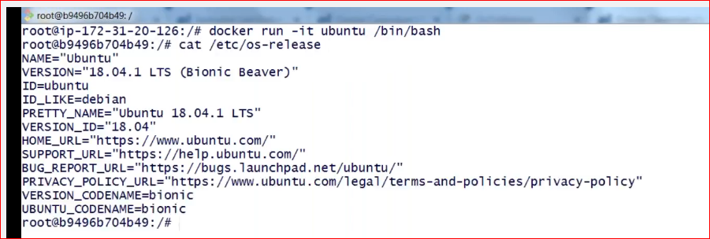

How to start a container?

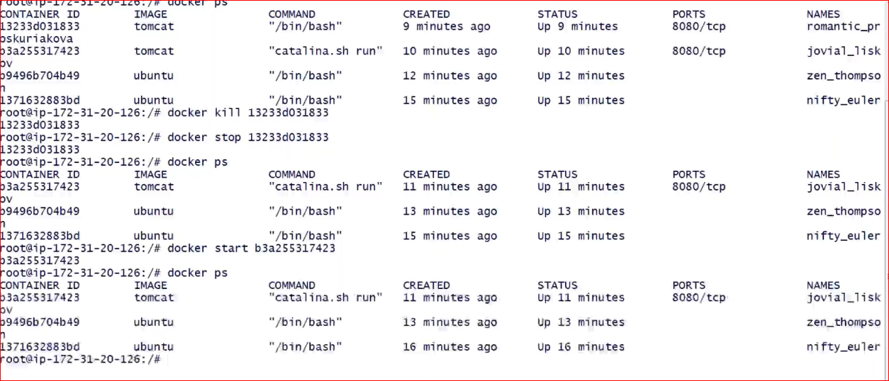

Difference b/w kill and stop

:**docker ps -a** gives the complete history of container

:how to run a container with exposing the port outside the container

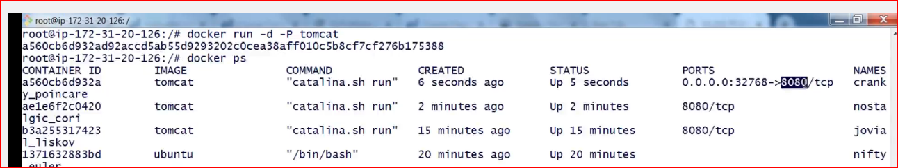

So here tomcat is running inside the container at 8080 but outside it can be accessed at 32768, docker creates this port no randomly

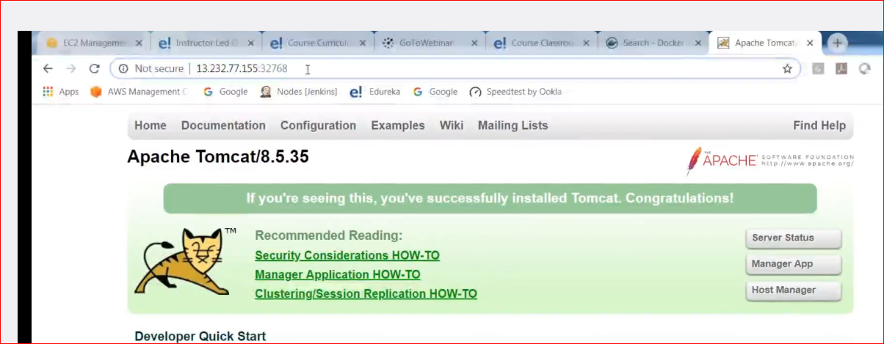

You can give ur own port no

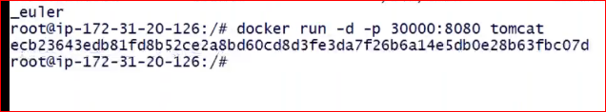

One thing to take care is to use small p here.

***one can stop, start multiple containers at a time

Install and run Jenkins

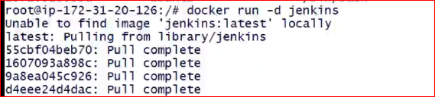

Get all the container id from ur machine, including running, stopped all the containers

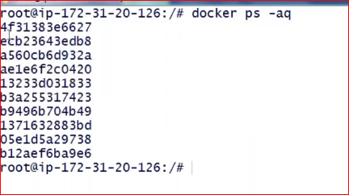

Copy contents from local to container

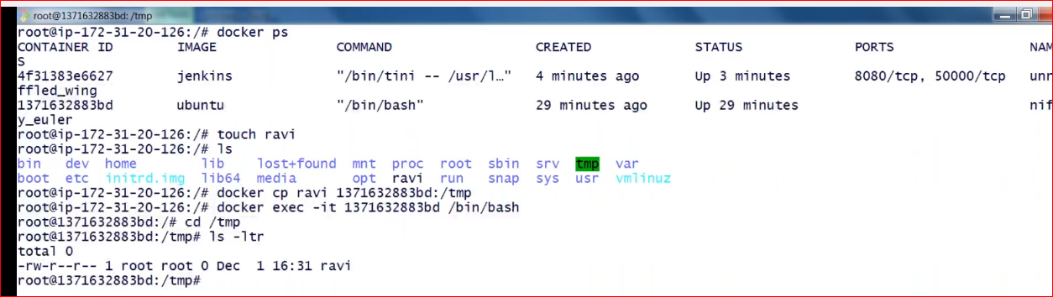

Note here we are using **docker exec -it** command to enter into the running container

Copy from container to our machine

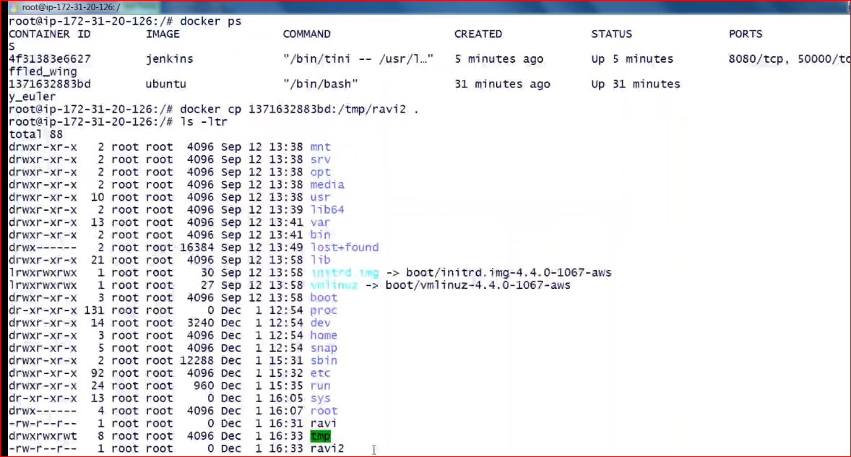

:saving or exporting a container

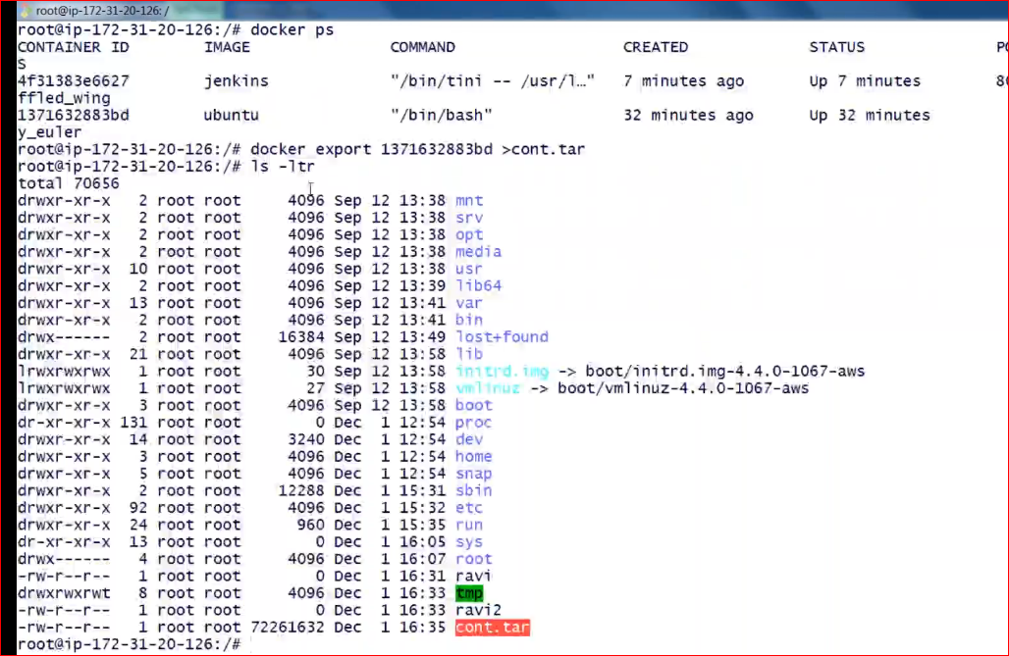

Importing a container as a new image

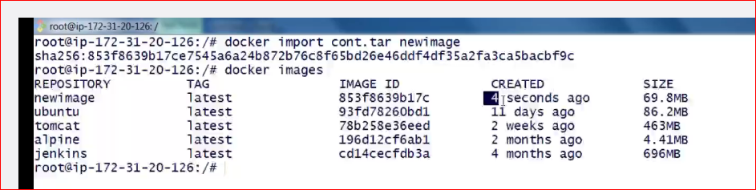

Docker inspect command to see the history

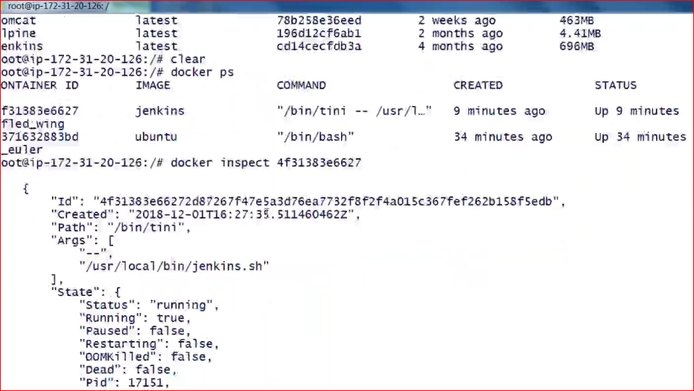

# Image Layers

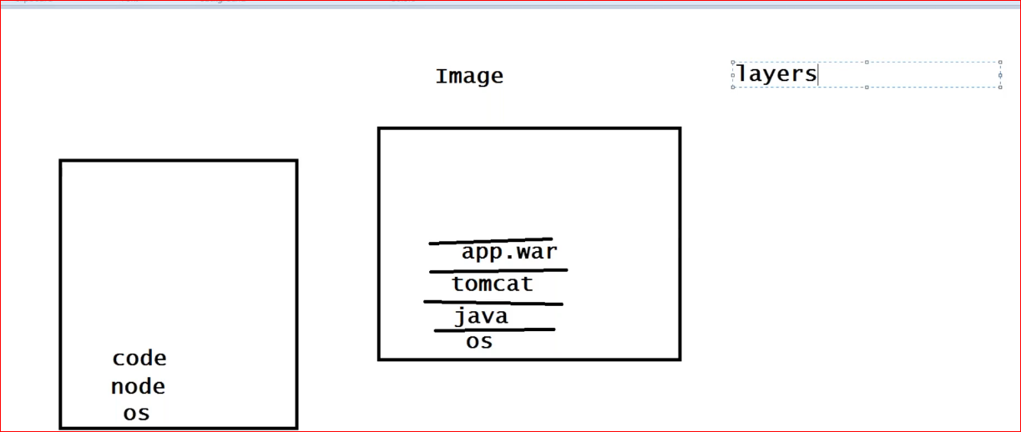

***Once the image is created, one cannot edit the image

Eg.. if u want to change the java version, u cannot do it.

One has to create new image

* + run as a container
  + make changes
  + create new image

Command to see the layers of the image

* **docker history tomcat**

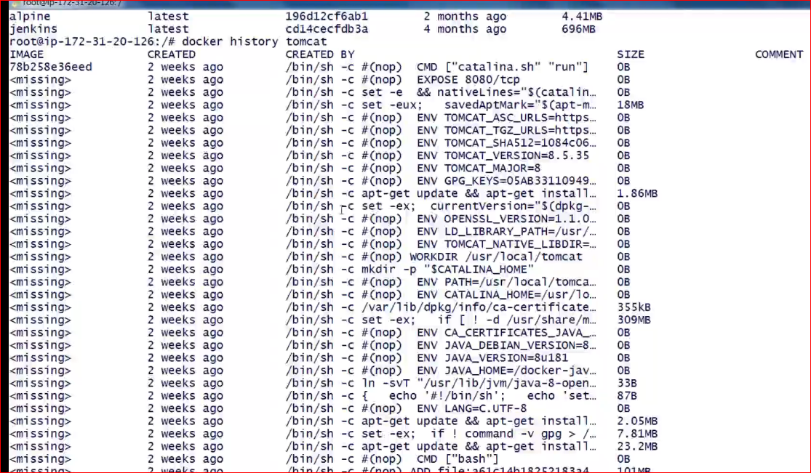

So for creating a new image take the base image, run it, go into the running container

Make changes, come out safely and commit the changes

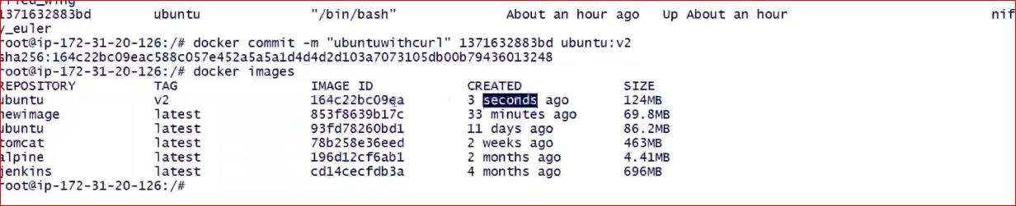

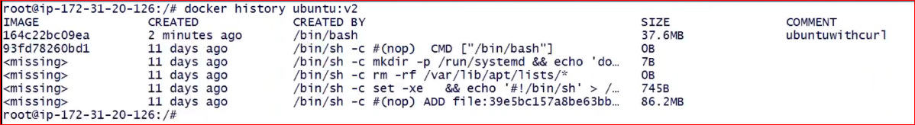

# Create a repository on docker hub

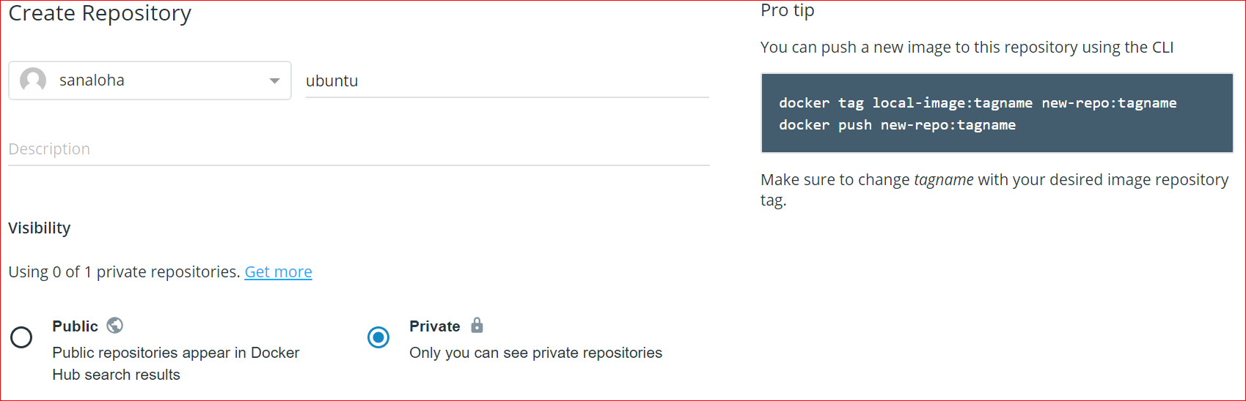

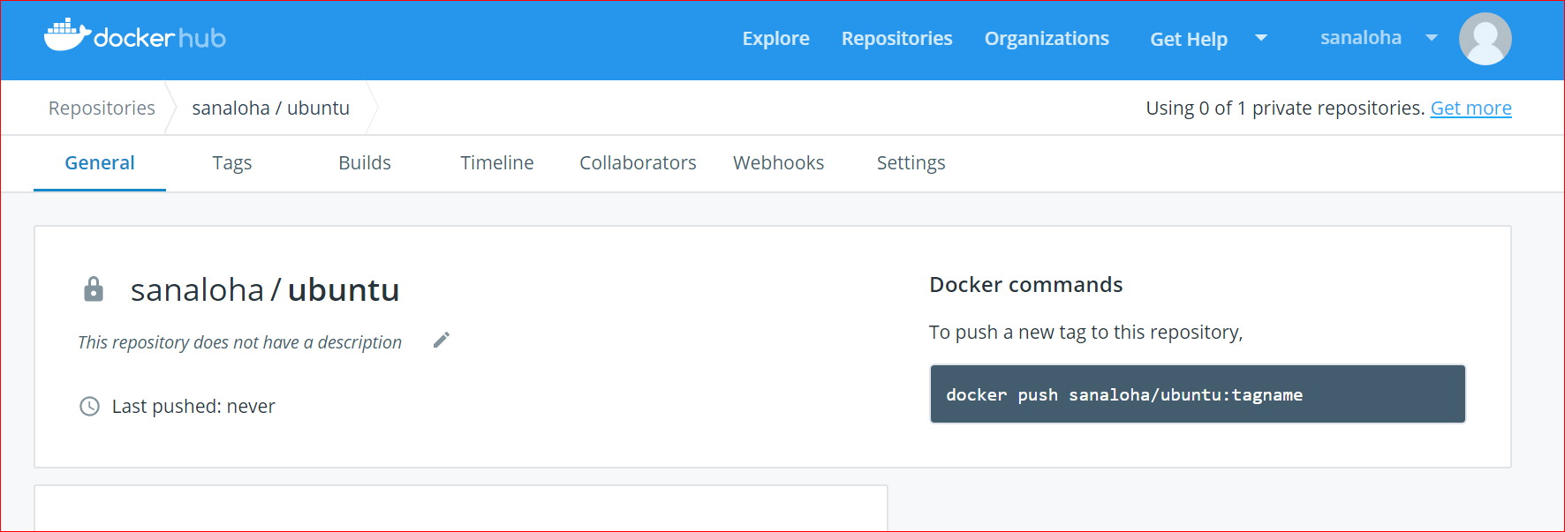

To make a push first tag the image

* docker images
* docker tag imageid …..

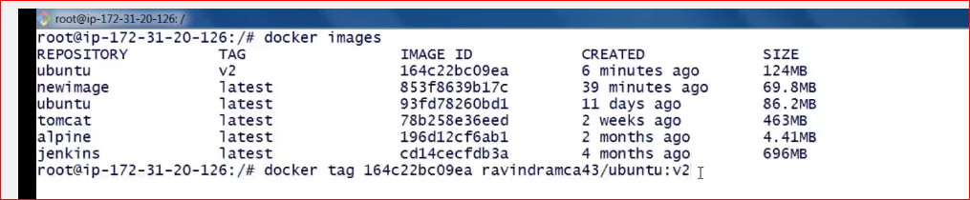  
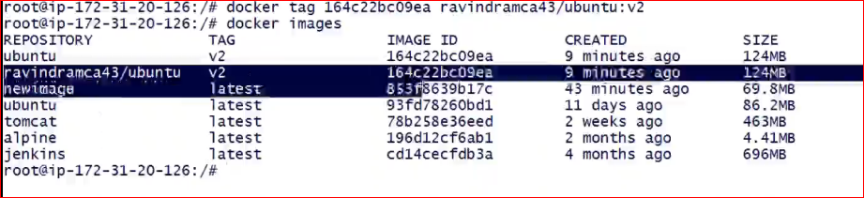

How to push?

First login and then push

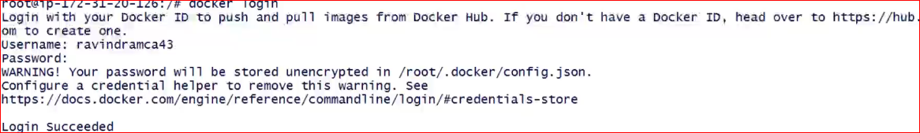

For private one, u need to give your url here



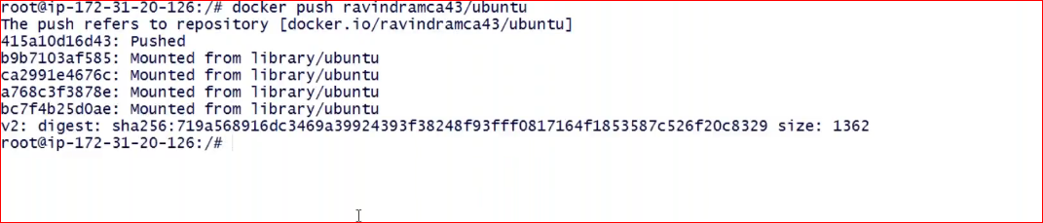

Got to docker hub

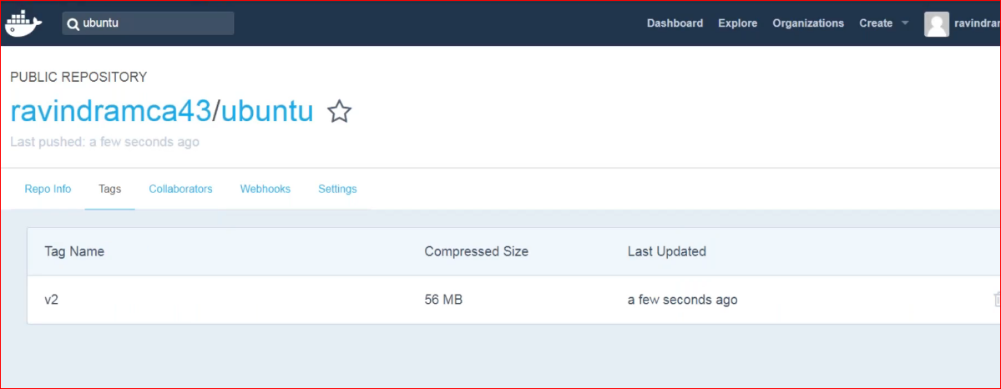

To remove use docker rmi command to remove and image

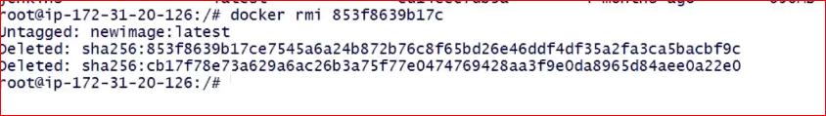

Make sure no container is running on this image.

# Create an image using docker file

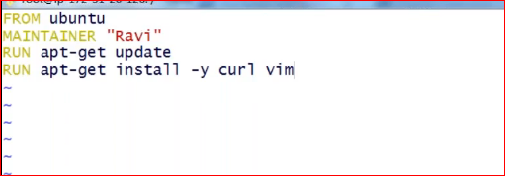

By default file name would be **dockerfile** only

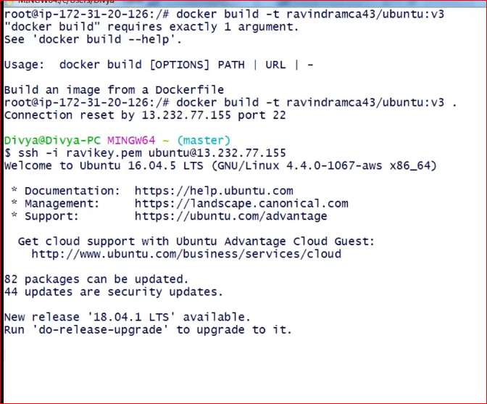

See if docker file is there or not

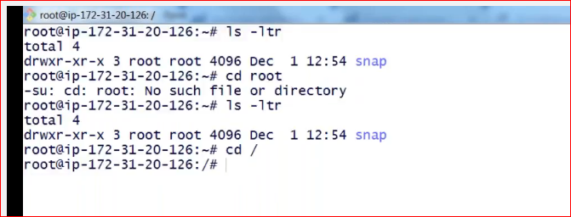

Create another docker file as shown below

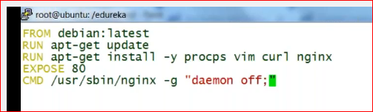

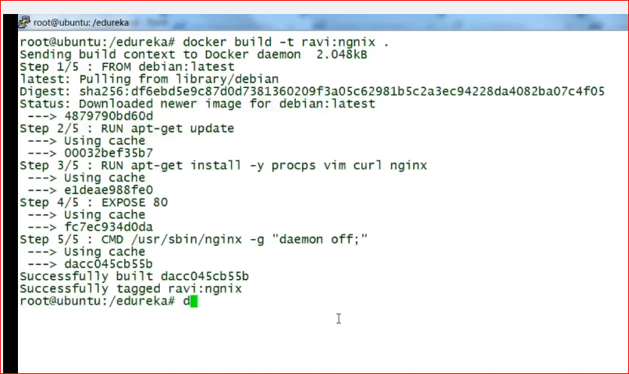

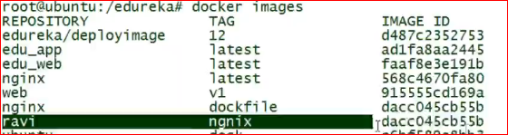

Run it

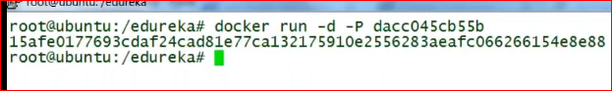



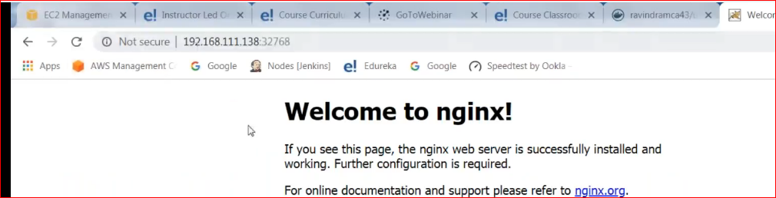

Install tomcat

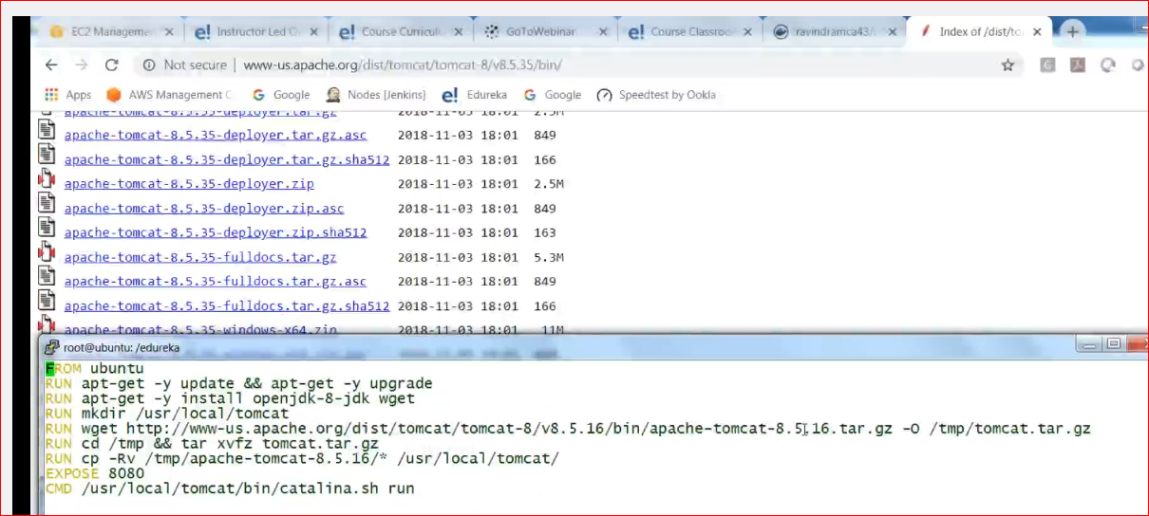

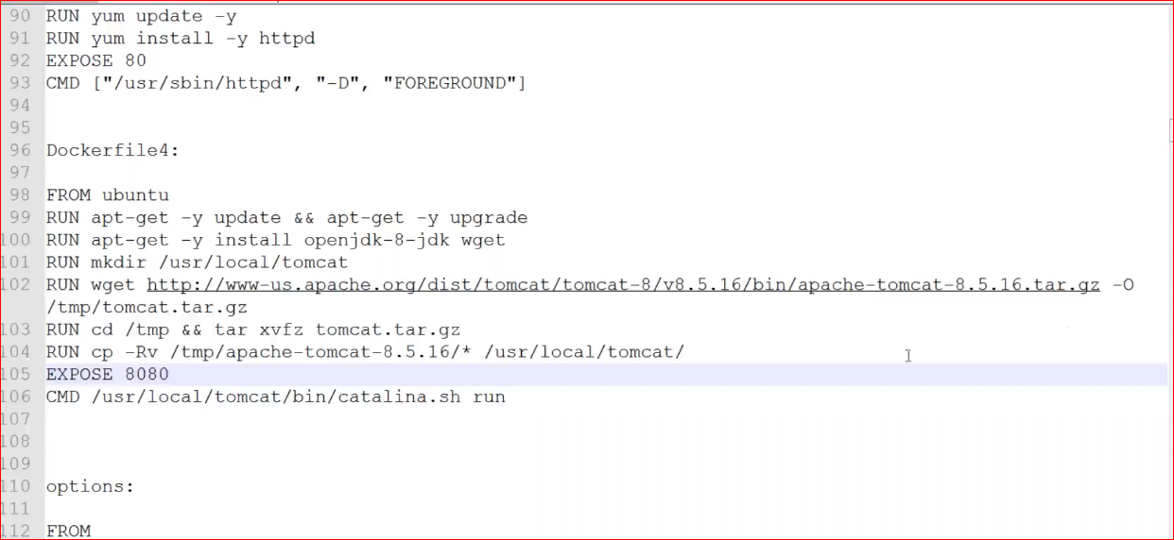

Lecture#8

# Docker Volumes

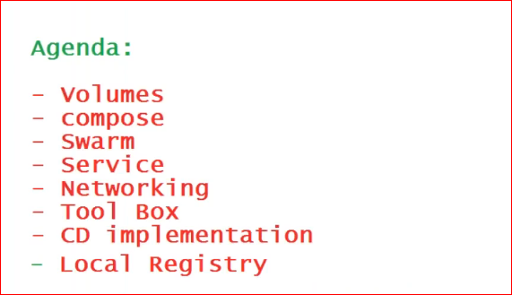

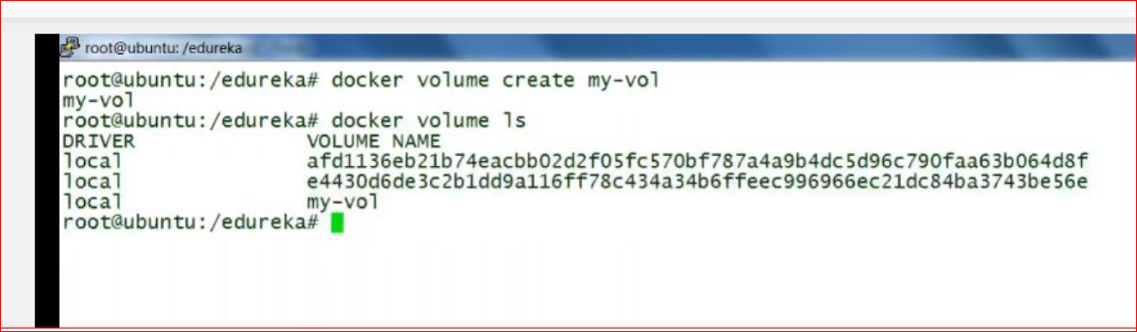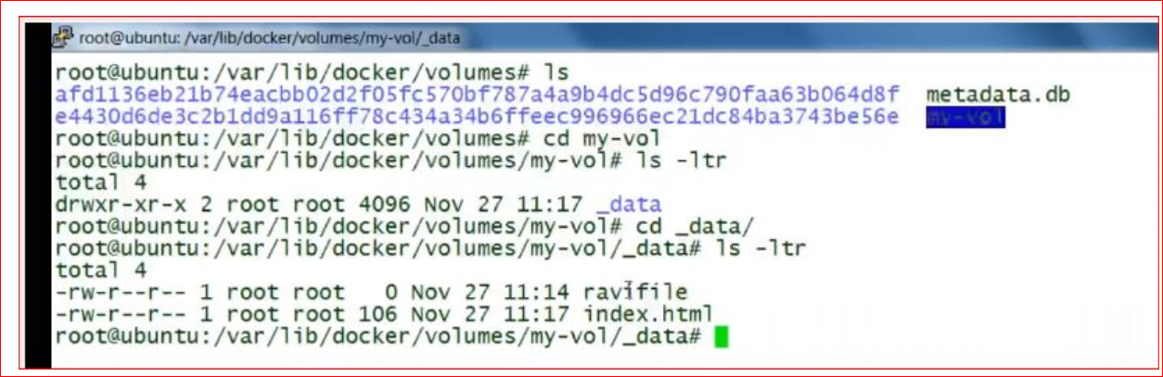

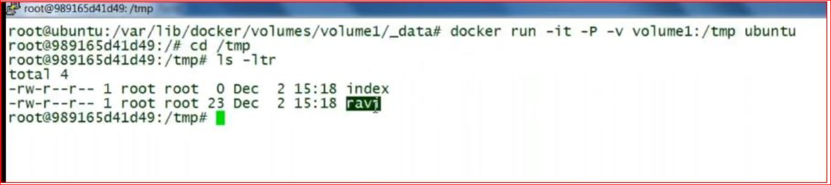

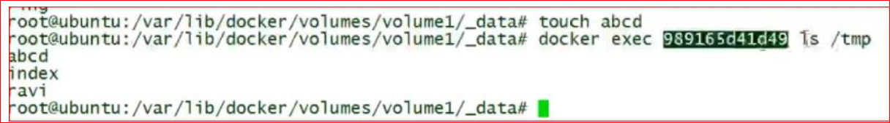

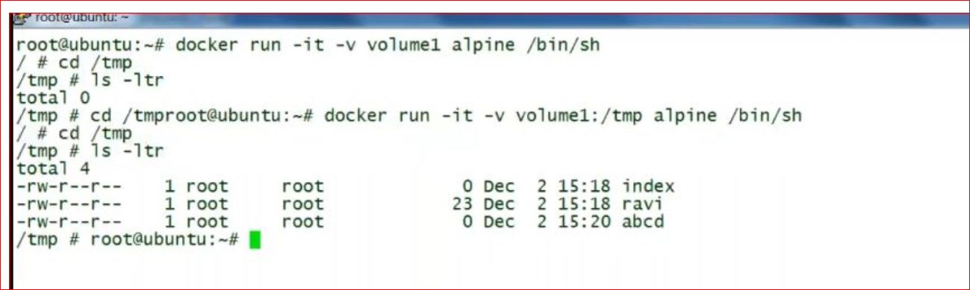

**So there r 2 ways of creating volume by docker create volume command and by**

**docker run with the internal path**

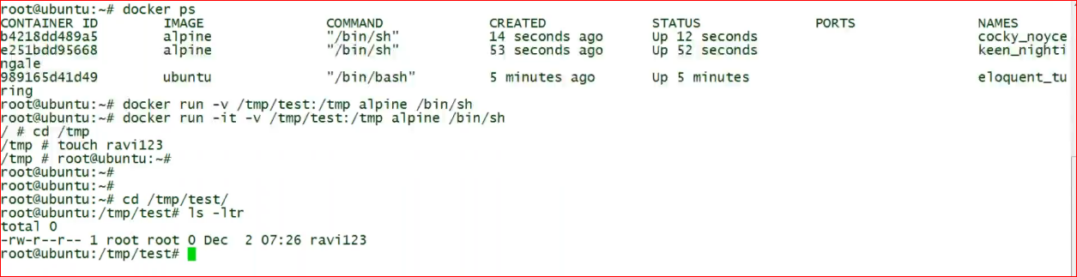

Check how many volumes are there

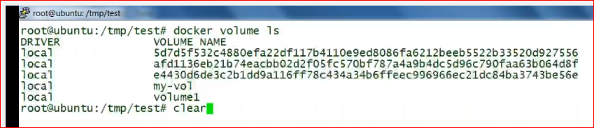

Delete a volume



**How to run multiple containers at a time?**

We need some kind of automation here

Scaling down or scaling up multiple instance, use docker compose

# Docker Compose

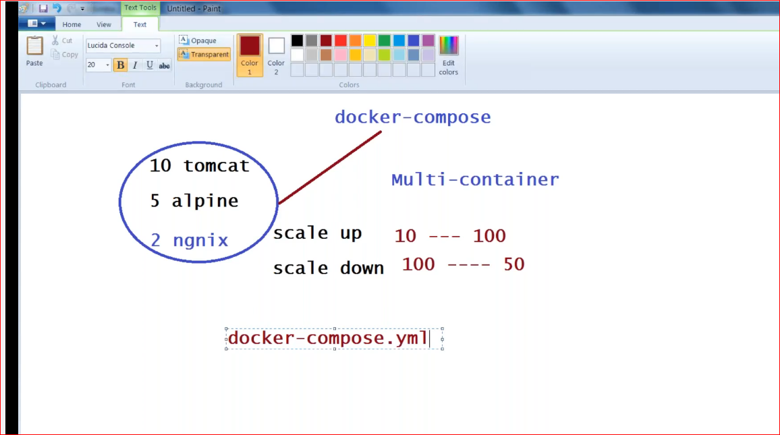

Download docker compose from github

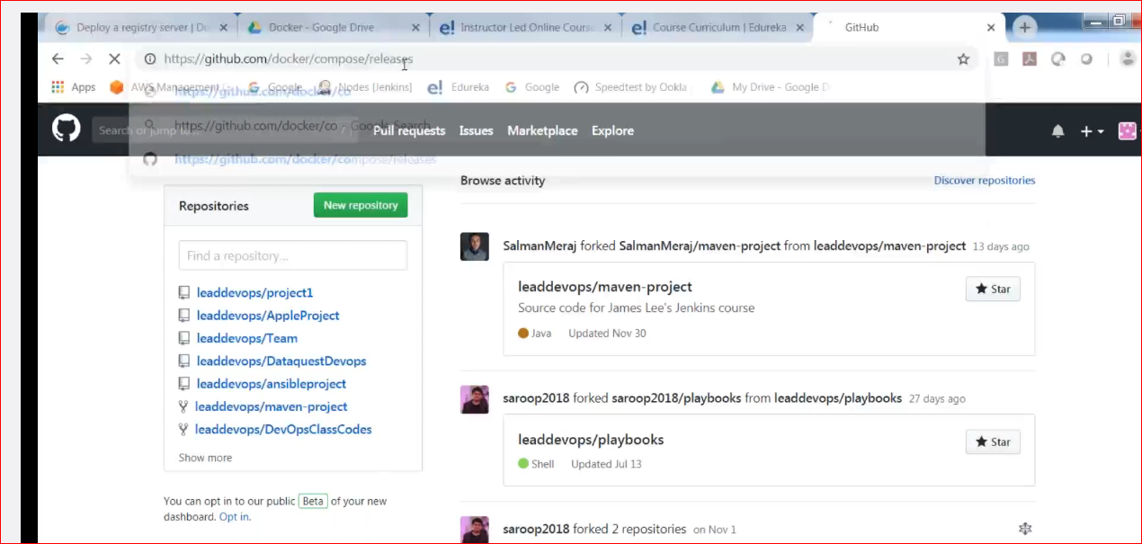

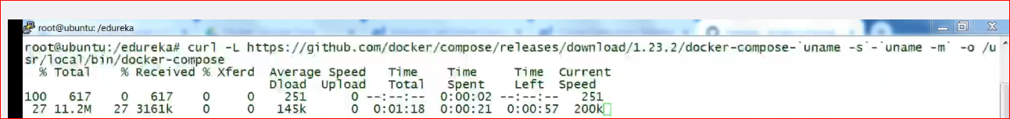

Now create compose file

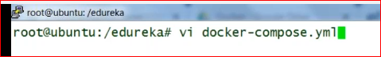

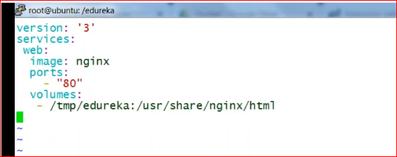

Create your html file

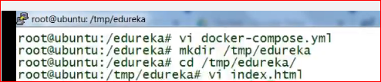

Now run the file

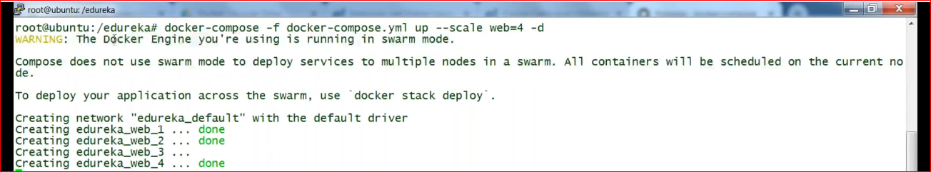

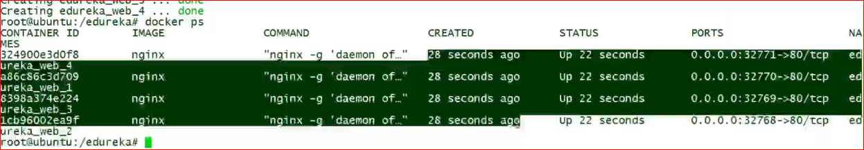

**\*\*\*Desired state**

Scale down

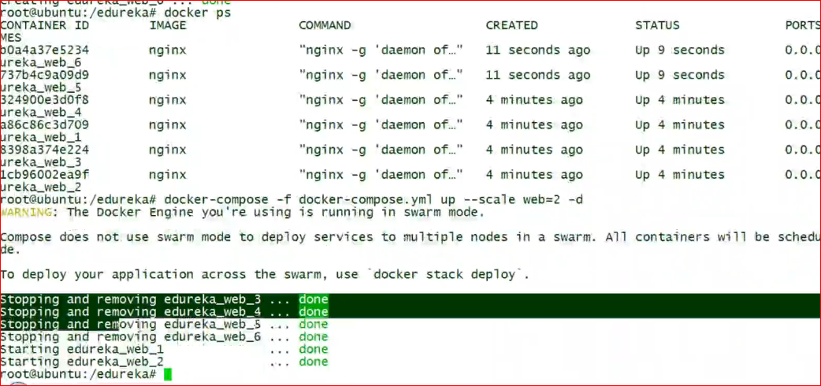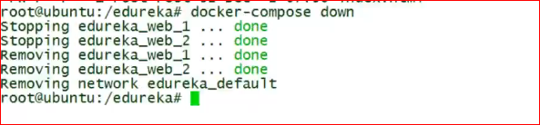

Now delete the existing one and create another compose file

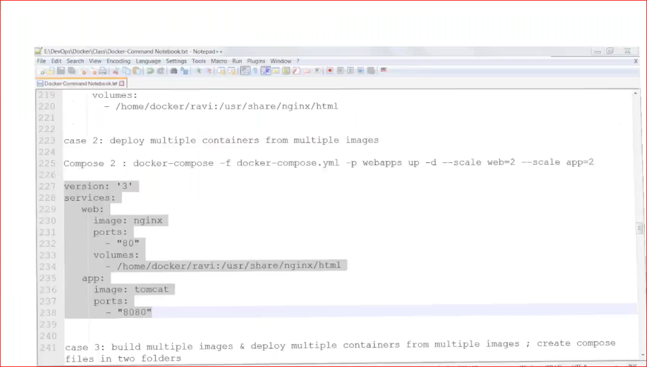

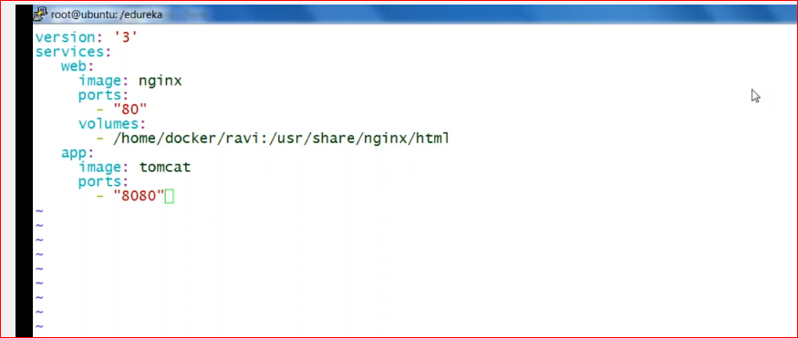

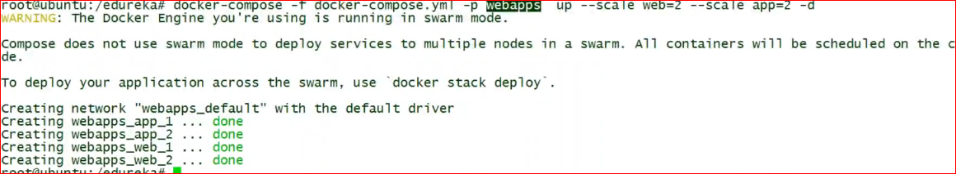

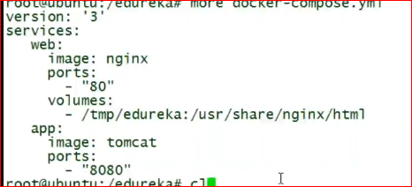

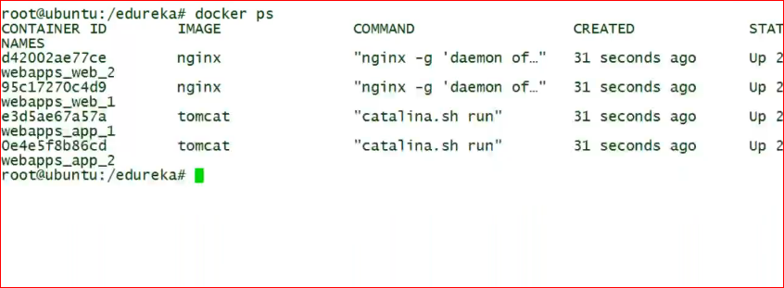

Now create another docker compose

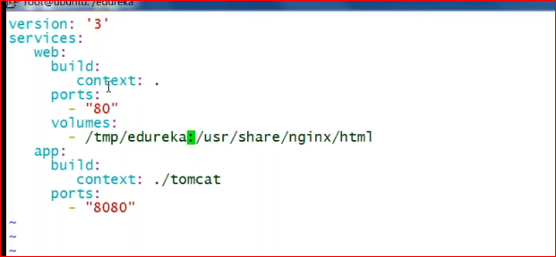

Difference here is we are not giving image

Here this command suggest to create an image using DockerFile then run it and exposed to 80 and use the volume

Two docker files we can’t create in the same folder so create another one at the folder ./tomcat for creating tomcat image.

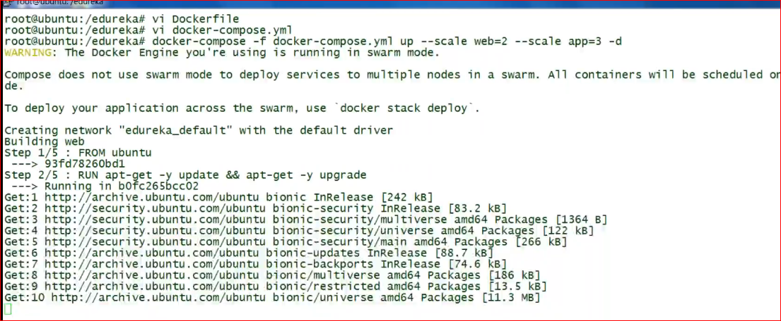

# Docker swarm

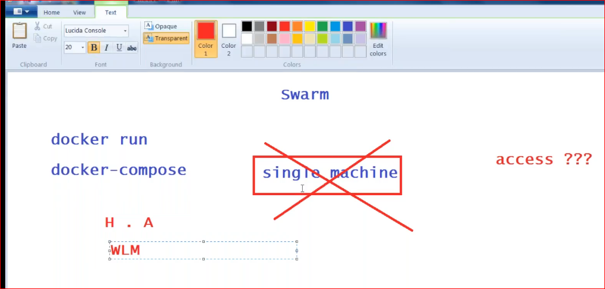

We need clustering

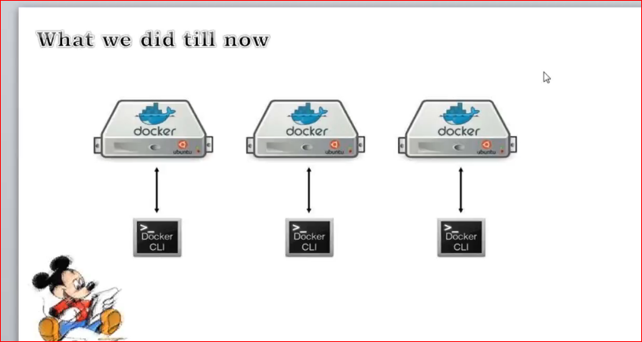

We run all the commands in manager and manager distributes the load to the nodes

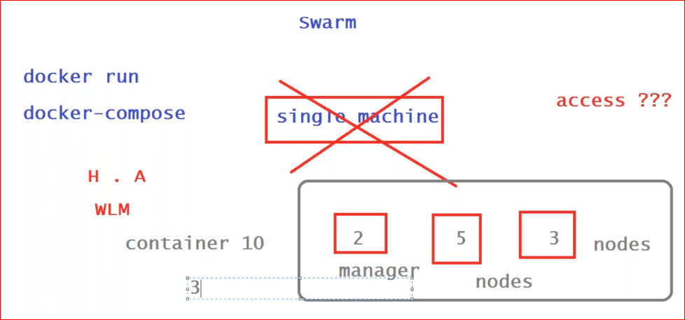

What if manager goes down, yes nodes will be still running

Play Ground for docker

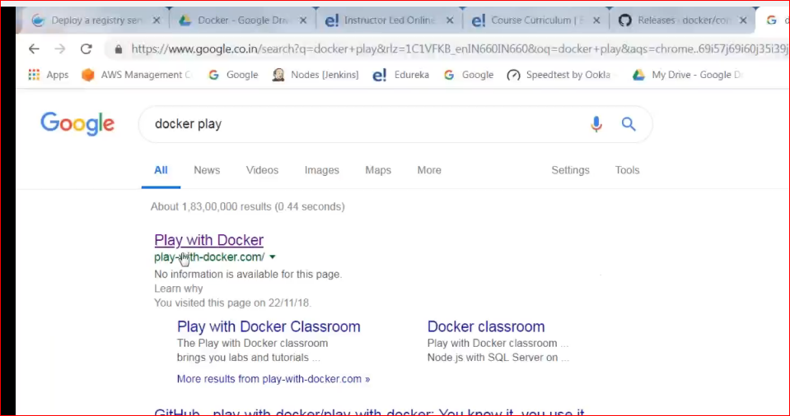

Login with docker hub credentials

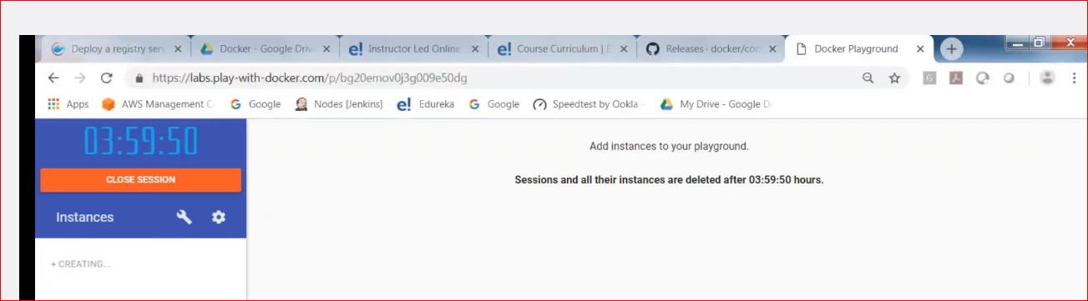

Add new instances

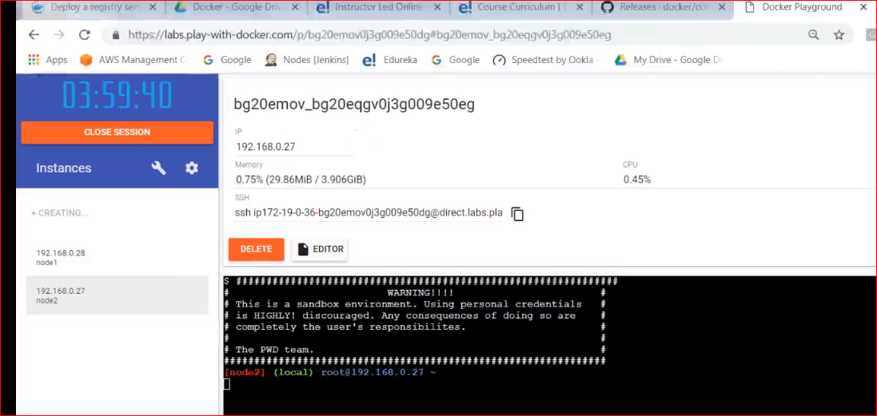

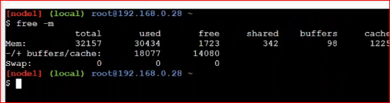

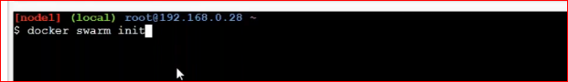

In play ground m/c u need to give the ip address

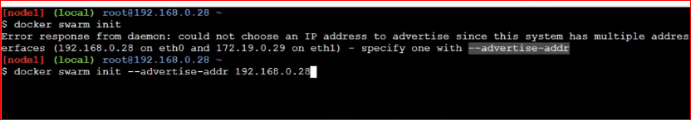

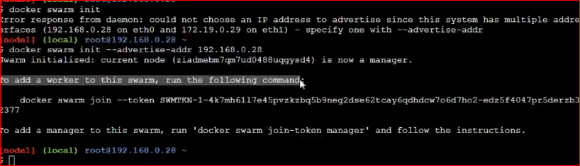

Run the worker on another m/c

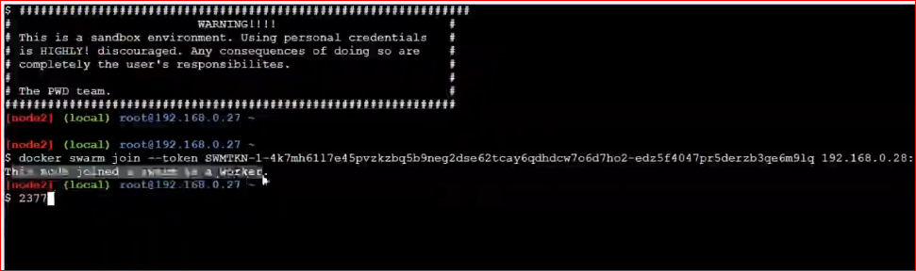

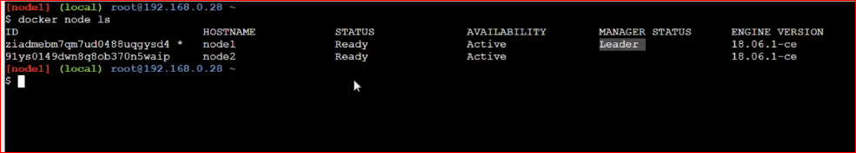

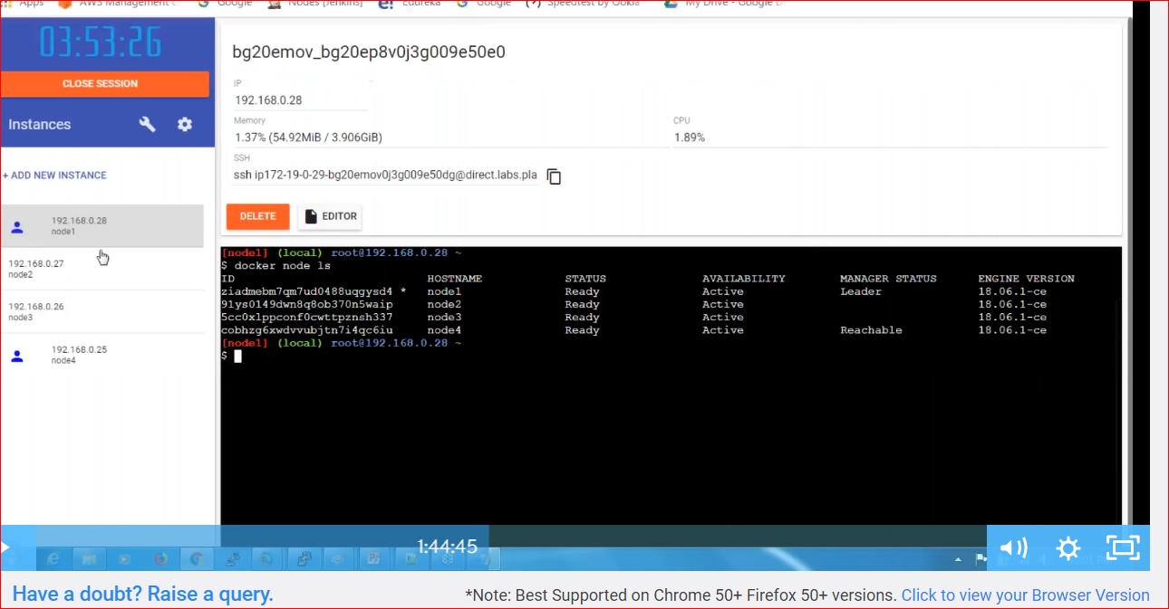

Docker node ls or any other command will run only one the manager

# Docker service

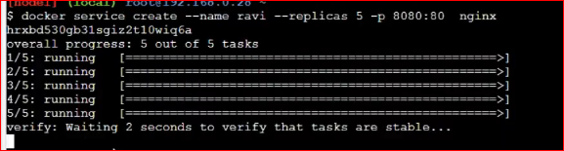

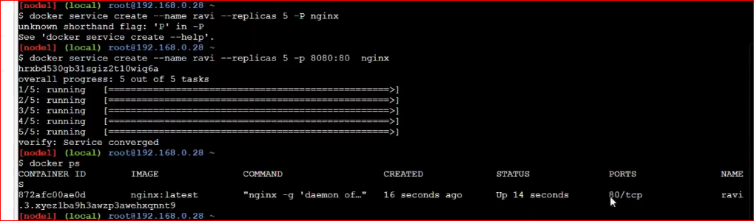

Check on every m/c

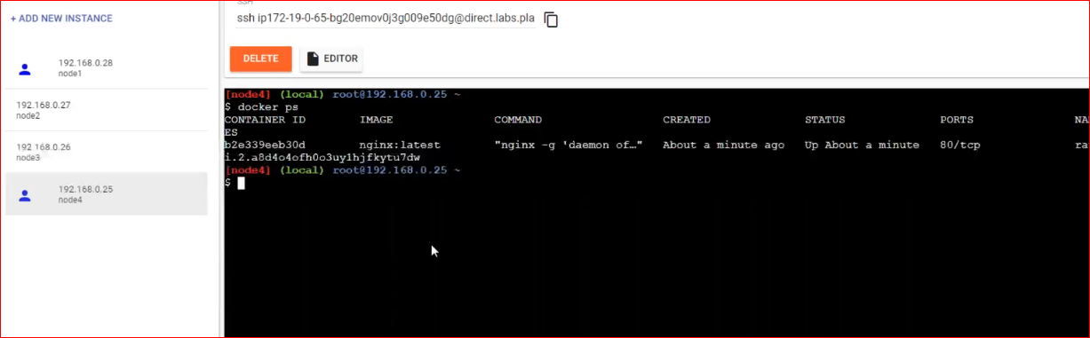

Drain means should not be any container running on node 1

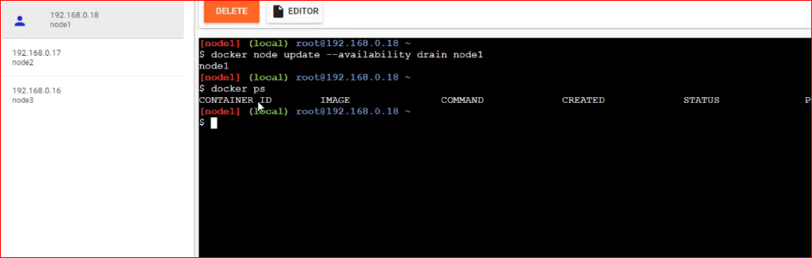

In this case 2 of the containers running on node1 i.e master shifted to node2 and node3.

To maintain the desired state

Make the node1 active again

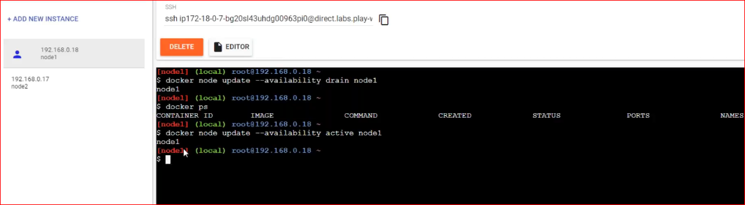

For multiple m/c u can use docker service for swarm instead of docker run or docker compose.

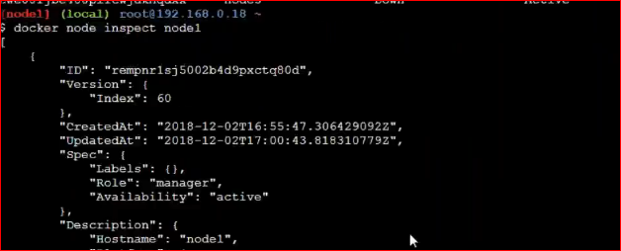

Which is better swarm and K8s? Obvious its K8s

ToolBox:

You can setup on ur windows

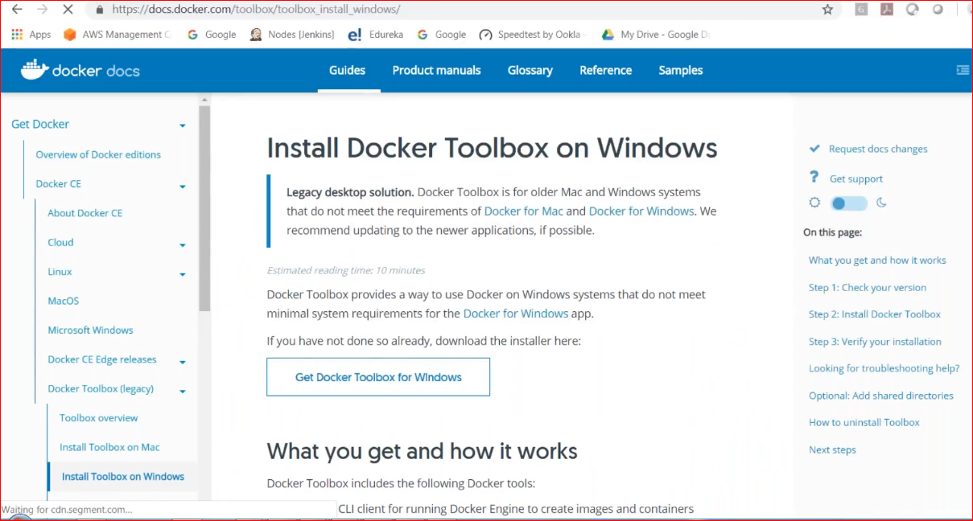

Before windows 10

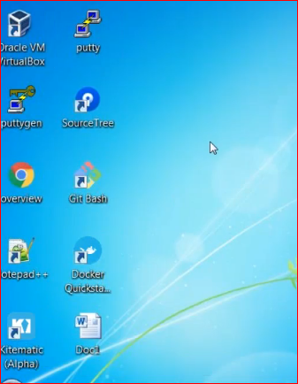

Kitematic: Kitematic use ur docker hub login. Never go with toolbox and kitematic

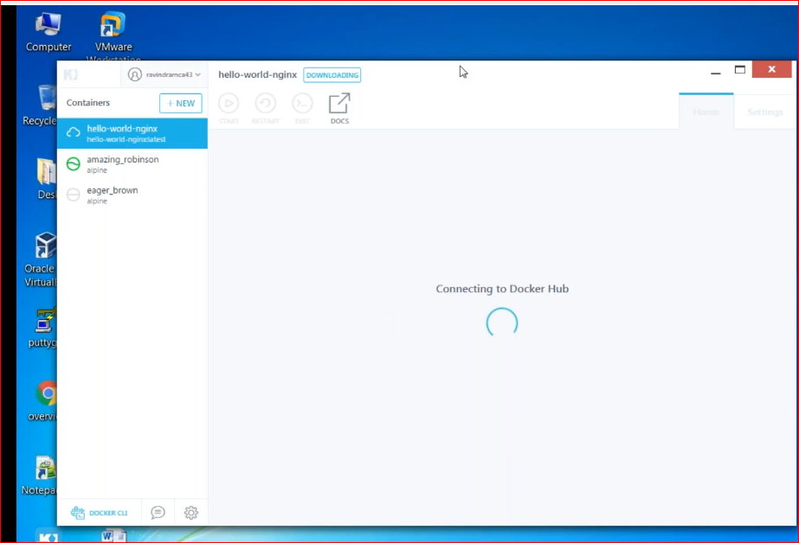

Is something like UI version of docker

Continuous Delivery

1. Create an image with the war file which is created via Jenkins
2. Run the container &
3. Access this war file

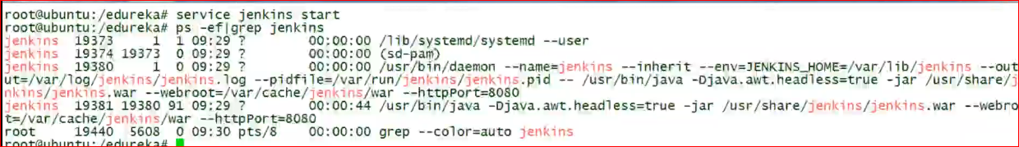

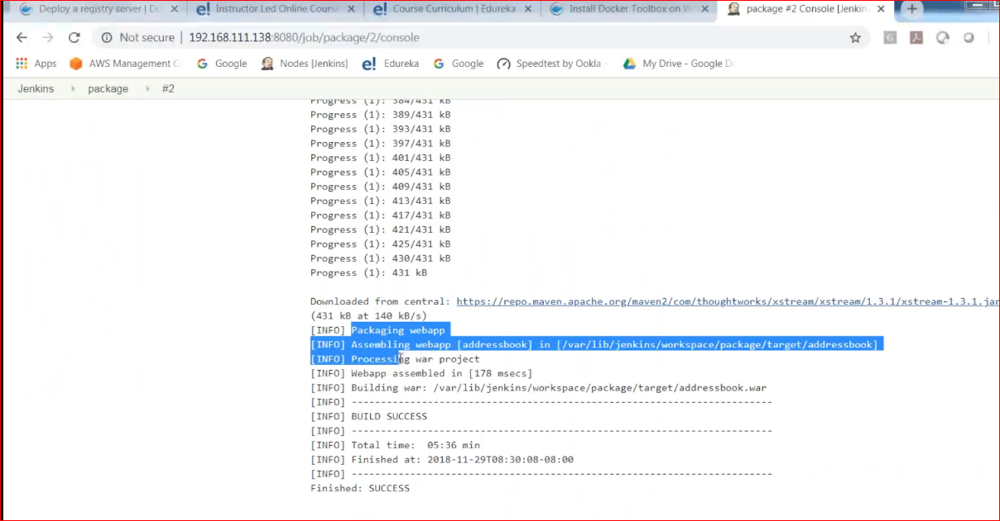

Create new deployment task in Jenkins

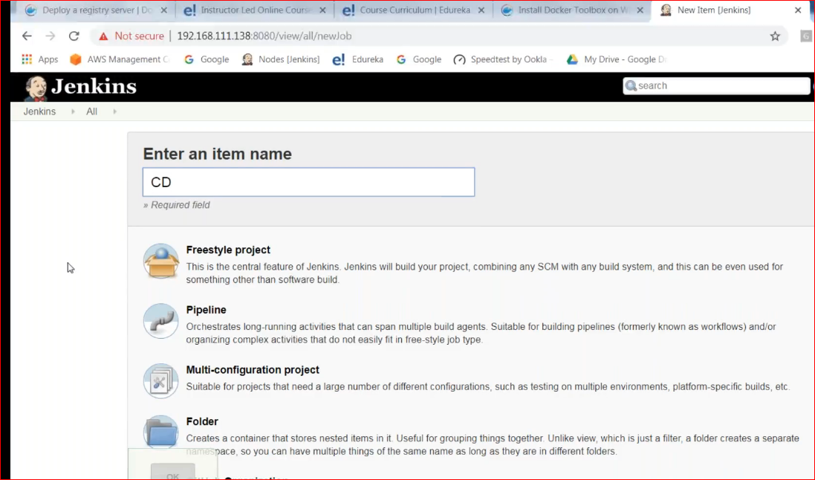

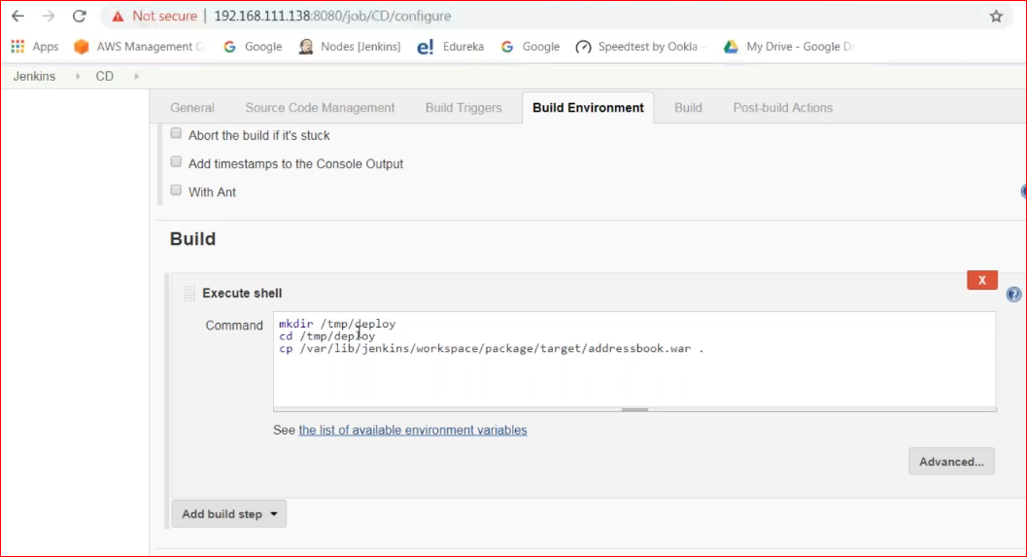

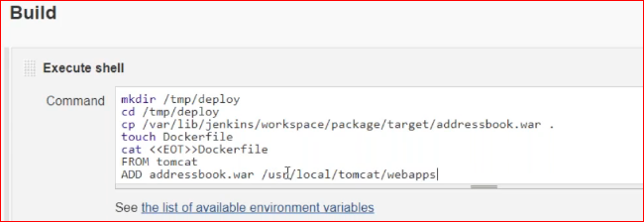

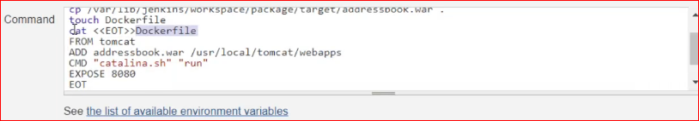

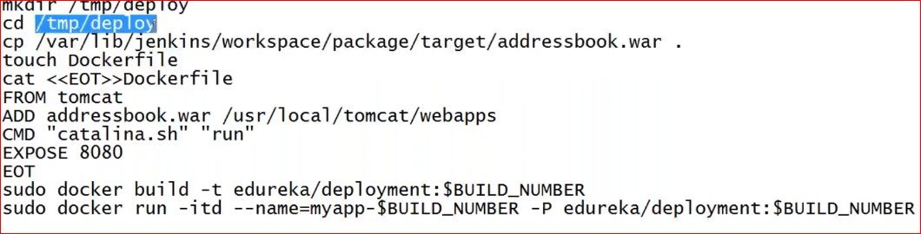

Runt the job on Jenkins and see on ur m/c

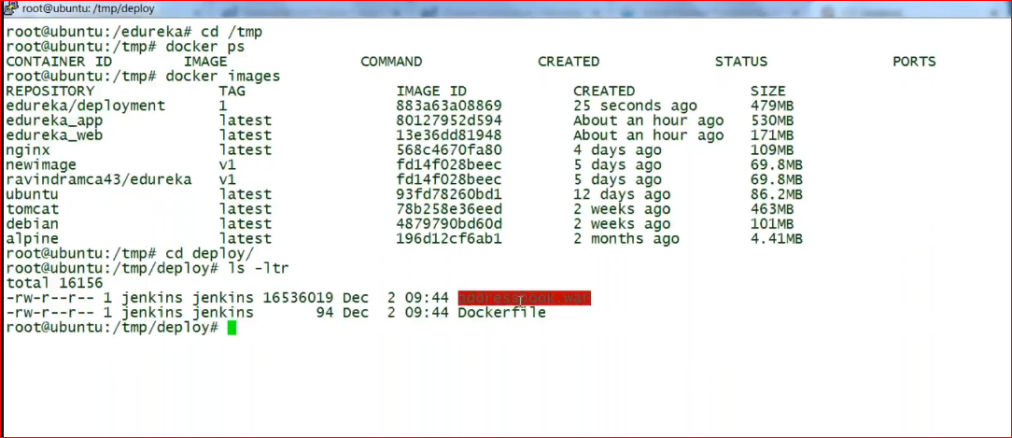

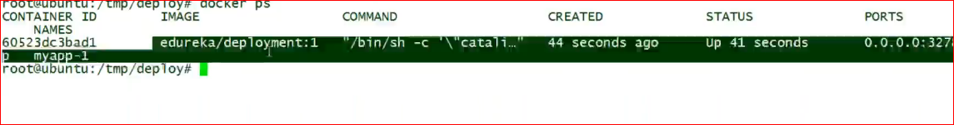

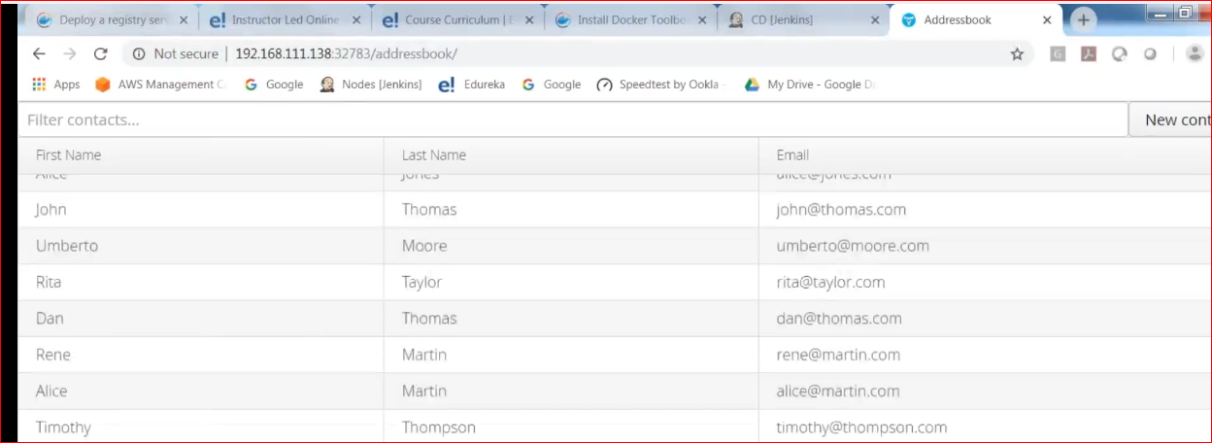

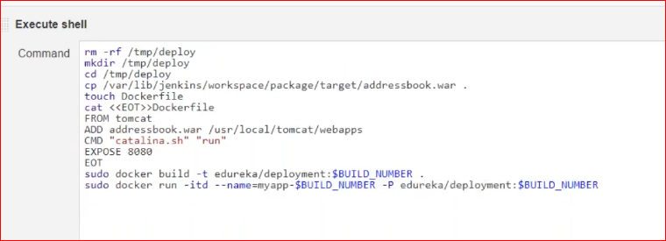

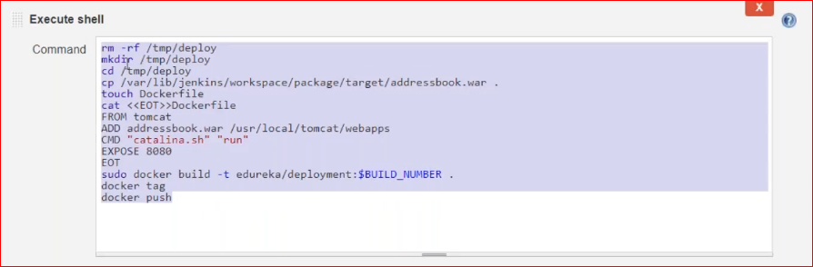

Install java

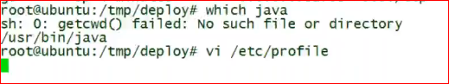

Export java path here

Run env to set the path

Docker networking

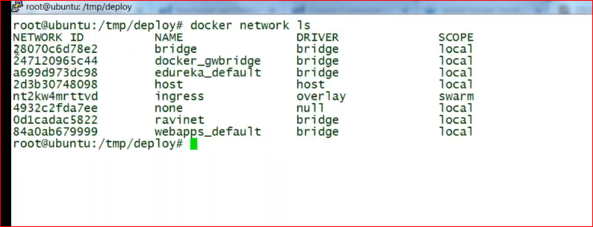

Shows available network types in docker

Whenever u run docker container by default it uses bridge

Host network: container uses same physical n/w of host

Ingress: only for swarm, m/c level n/w is used

None: no one can use the container

How to create ur own network in docker?

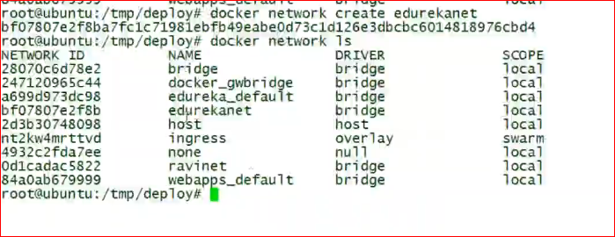



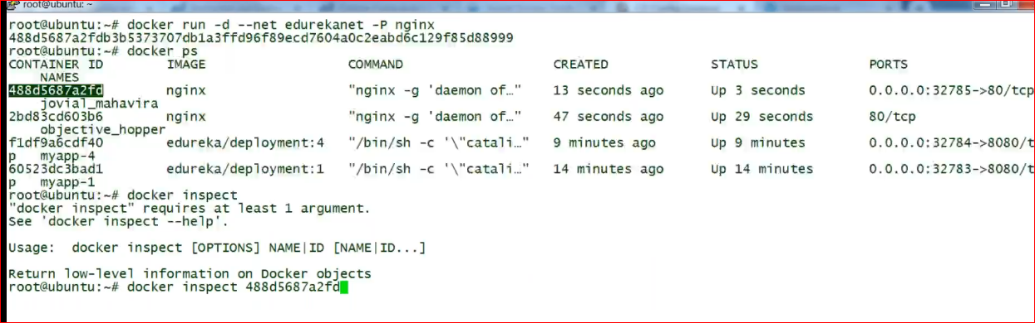

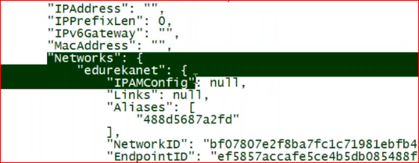

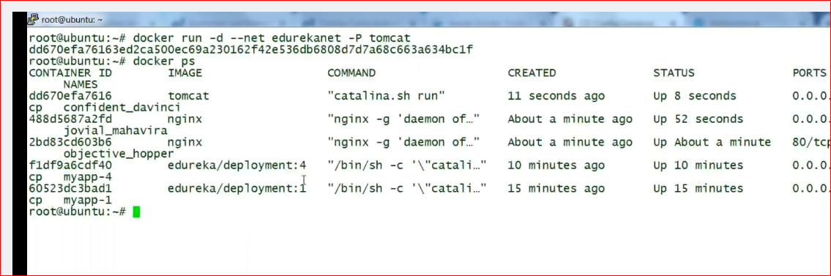

Now tomcat and ngnix are on the same n/w, u can pin tomcat from ngnix

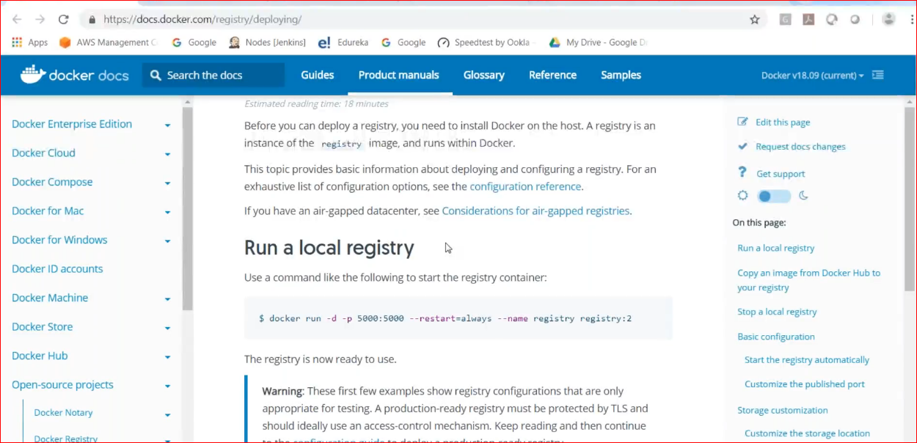

One do not want to goto docker hub every time

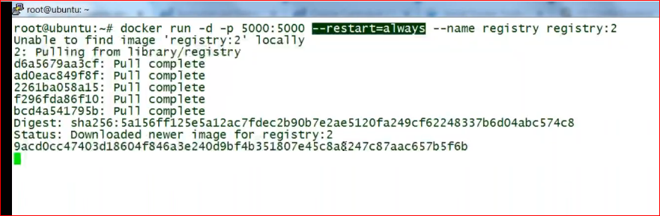

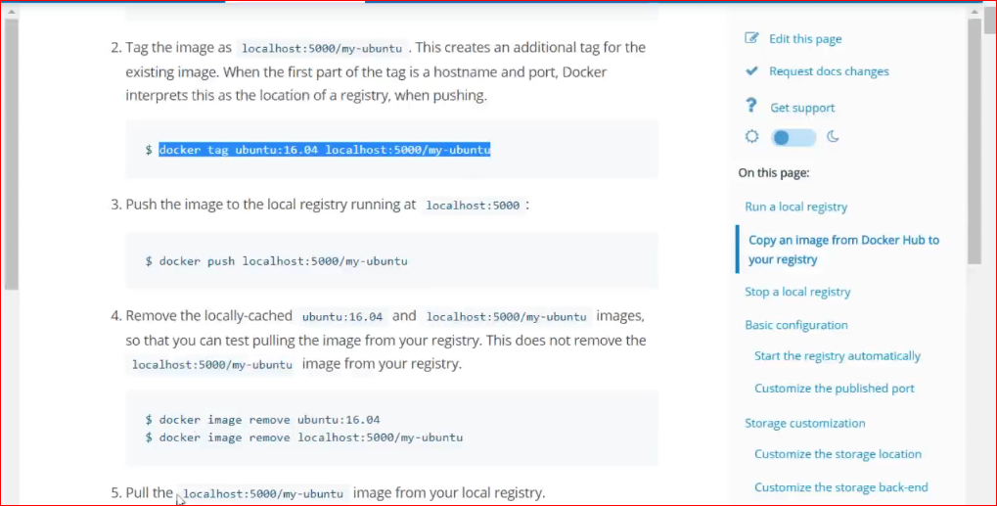

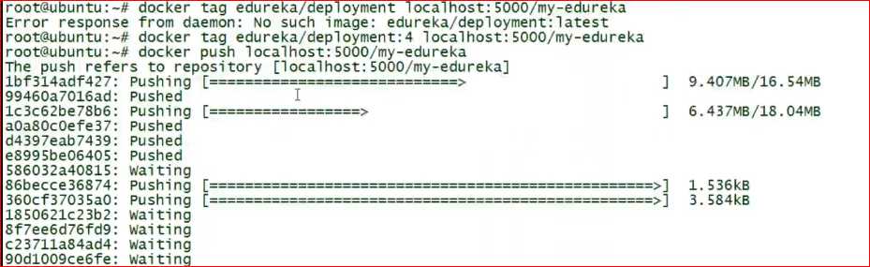

Use docker info command to see the repo

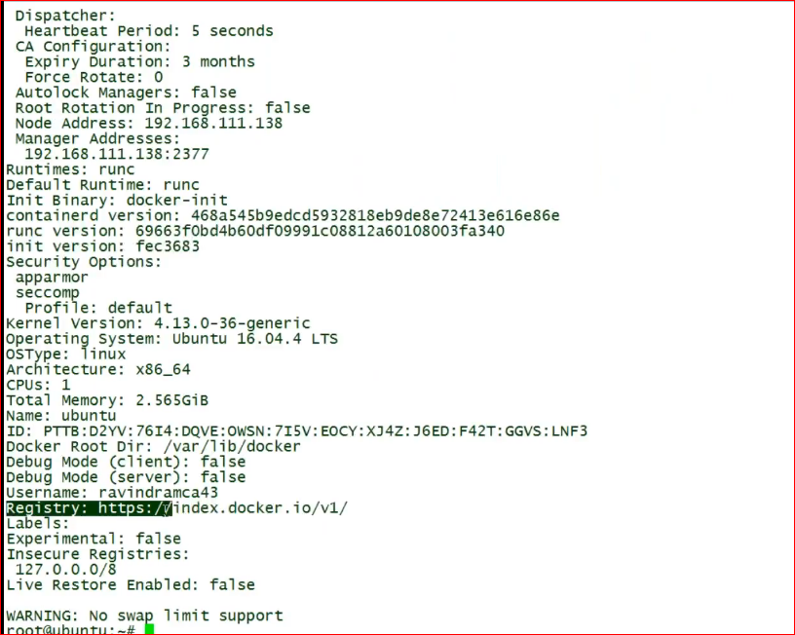

Clean not reachable containers

